**Automobile Management System**

By

**Prakhar Saxena**

**T.Deeraj Reddy**

**Pavan Kumar**

Submitted to the Department of Computer Science & Applications

in partial fulfilment of the requirements

for the Degree of

**BCA(Bachelor of Computer Application)**

in

Computer Science

 

University of Kota

Session : 2018-21

*Under the Esteemed Guidance of*

**Mrs. Varsha Yadav**

Assistant Professor

Dept. of Computer Science & Applications, MIMT, Kota

**Modi Institute of Management & Technology, Kota**



**CERTIFICATE**

Certified that project work entitled “**Automobile Management System”** is a bonafide work carried out by **Prakhar Saxena**, **Pavan Kumar** and **T.Deeraj Reddy** at MIMT, Kota. In partial fulfilment for the award of **BCA(Bachelor of Computer Application)** in Computer Science from University of Kota, during the academic year 2020-2021

_________________ _________________

**Name of External** **Name of Internal / Guide**

**Date:**

(Signature date)

Dept. of Computer Science & Applications

Modi Institute of Management & Technology,

Kota

**Acknowledgement**

Apart from the efforts of our. The success of any project depends largely on the encouragement and guidelines of others. We take this opportunity to express our gratitude to all those people who have been instrumental in the successful completion of the project.

We would like to show our greatest appreciation to my Lecturers **Mrs.Varsha Yadav**. We can’t say thank you enough for the tremendous support and help during those crucial times. We felt motivated and encouraged to do our best every time. Without her guidance this project would have not been materialized.

The guidance and support received from all the members who contributed and who are contributing to this project were vital for the success of the project. We are grateful for their constant support and help.

**Abstract**

**Project Name :** Automobile Management System

**Project Team :** Prakhar Saxena, T.Deeraj Reddy and Pavan Kumar

**Term :** 2020-21 (BCA Final Year)

**Objective :**

This system “**PTP Automobiles Management System**” allows providing vehicles for purchase, their services and their spare parts to attach. If customer got any problem with his vehicle, based on guarantee card we are providing services.

The real power of this project lies not in direct selling of products, but in the creation of tighter relationship with the customers and delivering of high level of service and support, which it turn improves organization sales and its goodwill. A service organization is a business entity that takes care of servicing, a customer instrument after sales domain. As the number of customers and size of operations increases, the organization divides the geographical area into service area and spare parts area, to allow engineers to be more responsive to the customer needs.

The Project contains mainly 3 modules -

* Purchases
* Selling
* Servicing

**TABLE OF CONTENTS**

Page

ACKNOWLEDGEMENTS....................................................................................... iii

ABSTRACT............................................................................................................... iv

1. INTRODUCTION......................................................................................... 1
2. STATEMENT OF PROBLEM..................................................................... 2
3. Proposed Solutions ……………………………………………………….... 3
4. Database Layer ….......................................................................................... 4
   1. DFD.......................................................................................................... 4
   2. Tables…………………………………………………………………... 5
5. External Interface…………………………………………………............... 7
   1. Hardware Interface……………………………………………………... 7
   2. Software Interface…………………………………………………….... 8
6. Process Logic Layer………………………………………………………... 9
   1. Coding………………………………………………………………….. 10
   2. Input Specification……………………………………………………... 93
   3. Output Specification…………………………………………………… 94
7. Conclusion………………………………………………………………….. 95
8. Future Scope………………………………………………………………... 96

REFERENCES…………………………………………………………………. 97

1. **Introduction**

The proposed project is developed to manage the automobile in the automobile dealer company.

The main module in this project is – Login, Oorder To Manufacturer, Order From Customer, Servicing, Spare Parts.

The first and main module is the Login module. The showroom members should login to the project for usage. The Username and Password are verified and if it is correct, then next form opens. If the Username and Password are not correct, then it shows the error message.

When a Customer demands a vehicle, if the vehicle is available, they will be taken to a page that is “Take Order” / “ofc”. PTP Automobiles is useful for establishing good relation between Customers & the Organization and between Manufaturer & the Organization.

When a Customer wants Spare Parts of his vehicle, if the parts is available, then they will be taken to a page that is “Spare Parts”.

1. **Statement of Problem**

* In most of cases the Indian showroom’s software is not reach internationally, and if they reach international market, then they does not give international vehicles for services and extra spare parts to attach to their vehicles.
* In our organization, we reach in international market and we set good communication with our manufacturer companies and then we order from it and then sell it to our customers.
* And we also give service to their vehicles and give facility for attach spare parts.
* User can not search vehicle fast, when the Id and Number is wrong.
* Primary key fields should be used whenever necessary while designing in order to manage database efficiently for accessing information soon.
* Existing system is not accurate.
* If the entries have duplicate values, it can not be maintained properly and accurately.
* Even though some existing system are computerized, there occur redundancy problem due to duplication of entries.
* Difficult to maintain duplicate vehicle details and duplicate employee details.

1. **Proposed Solutions**

The proposed system is very usful for the Employees and the Customers. It avoids the overhead for the employee. They can minimize the working stress and can keep essential documents related to the automobile. The advantage of the proposed system is the reduction in the cost and the transaction is done quickly.

The proposed project will allow the employee to perform certain activities like Login, Saving records, Serching, Updating and Deleting records.

In Login form, user will be authenticated and it is also possible to find whether their login information which was entered is right or wrong. A employee must be logged in before saving, searching, updating and deleting records.

If a user attempts to login with incorrect details, they will not be redirected to access the application.

When a employee search for a order, service and spare parts, they will be taken to a page that shows the details of the vehicle.

1. **Database Layer**
   1. **DFD(Data Flow Diagram) :-**

**0 Level DFD :-**

**1 Level DFD :-**

***Save Order***

***Save Order***

***Save Order***

***Save Order***

**DB**

**PTPAutomobiles**

***Give* *Order***

**If Customer Requested**

***Request* *Order***

**Customer**

**Employee**

***Supply Requested Order***

***Required* *Order***

***Give* *Order***

***Request* *Order***

**Manufacturer**

**Customer**

**2 Level DFD :-**

**Sign-Up**

**DB**

**PTPAutomobiles**

**DELETE**

**SAVE**

**UPDATE**

**OR**

**OR**

**AND**

**OR**

**Employee**

**Customer**

**Login**

* 1. **Tables**

Database Name : PTPAutomobiles.

Tables :-

**Employee Table**

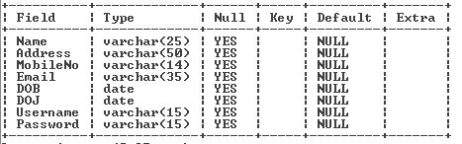

**OrderToManufacturer Table**

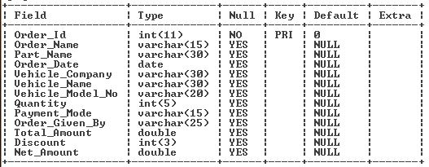

**OrderFromCustomer Table**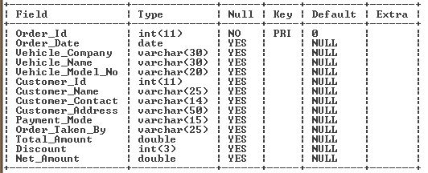

**Servicing Table**

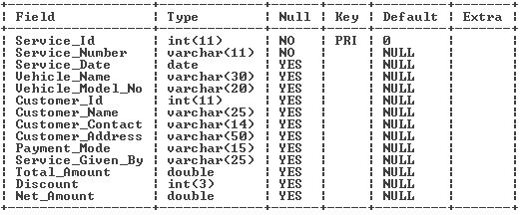

**SpareParts Table**

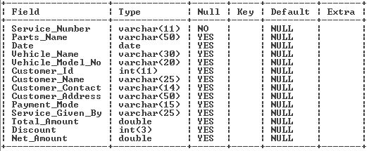

1. **External Interface**

**5.1** **Hardware Interface**

|  |  |
| --- | --- |
| Processor : | Dual Core / 1.8GHz or more |
| Memory : | 2 GB RAM or more (Suggested) |
| Hard Disk : | 2 GB for store Application & Database (Minimum) |

**Hardware Requirements :-**

We can use lowest Hardware requirements like Dual Core and 1.8GHz speed processor for this application.

And for Memory, we can can use minimum 2GB RAM for run this application.

And we can store application files and database in minimum 2GB of Hard Disk.**5.2** **Software Interface**

|  |  |
| --- | --- |
| Operating System : | Windows XP and advance versions |
| Frontend : | Visual Basic 6.0 |
| Backend : | MySQL Server 5.1 |

**Software Requirements :-**

**Operating System -** Windows 7 is used as the operating system as it is stable and supports more features and is more user friendly.

**Frontend -** VB 6.0(Visual Basic 6.0) is easy to use and easily to design applications for any other user.

**Backend -** MySQL is used as database as it easy to maintain and retrieve records by simple queries which are in English language which are easy to understand and easy to write.

1. Process Logic Layer

**Login Process :-**

**Order Taken and Given Process :-**

**PTPAutomobiles**

**Servicing**

**Order From Customer**

**Order To Manufacturer**

**Spare Parts**

**Home**

**Home**

**Sign-Up**

**Welcome**

**PTPAutomobiles**

**Login**

* 1. **Coding** 
     1. **Module Coding -**

Public dbconn As New ADODB.Connection

Public recset As New ADODB.Recordset

Public Sub dbconnection1()

dbconn.Open "provider=MSDASQL;driver={Mysql ODBC 3.51 Driver};database=PTPAutomobiles;server=localhost;user=root;password=123"

recset.Open "select * from OrderToManufacturer", dbconn, adOpenDynamic, adLockOptimistic

End Sub

Public Sub dbconnection2()

dbconn.Open "provider=MSDASQL;driver={Mysql ODBC 3.51 Driver};database=PTPAutomobiles;server=localhost;user=root;password=123"

recset.Open "select * from OrderFromCustomer", dbconn, adOpenDynamic, adLockOptimistic

End Sub

Public Sub dbconnection3()

dbconn.Open "provider=MSDASQL;driver={Mysql ODBC 3.51 Driver};database=PTPAutomobiles;server=localhost;user=root;password=123"

recset.Open "select * from Servicing", dbconn, adOpenDynamic, adLockOptimistic

End Sub

Public Sub dbconnection4()

dbconn.Open "provider=MSDASQL;driver={Mysql ODBC 3.51 Driver};database=PTPAutomobiles;server=localhost;user=root;password=123"

recset.Open "select * from SpareParts", dbconn, adOpenDynamic, adLockOptimistic

End Sub

Public Sub dbconnection5()

dbconn.Open "provider=MSDASQL;driver={Mysql ODBC 3.51 Driver};database=PTPAutomobiles;server=localhost;user=root;password=123"

recset.Open "select * from Employee", dbconn, adOpenDynamic, adLockOptimistic

End Sub

Public Sub closeDB()

Set dbconn = Nothing

Set recset = Nothing

End Sub

* + 1. **Process Form -**

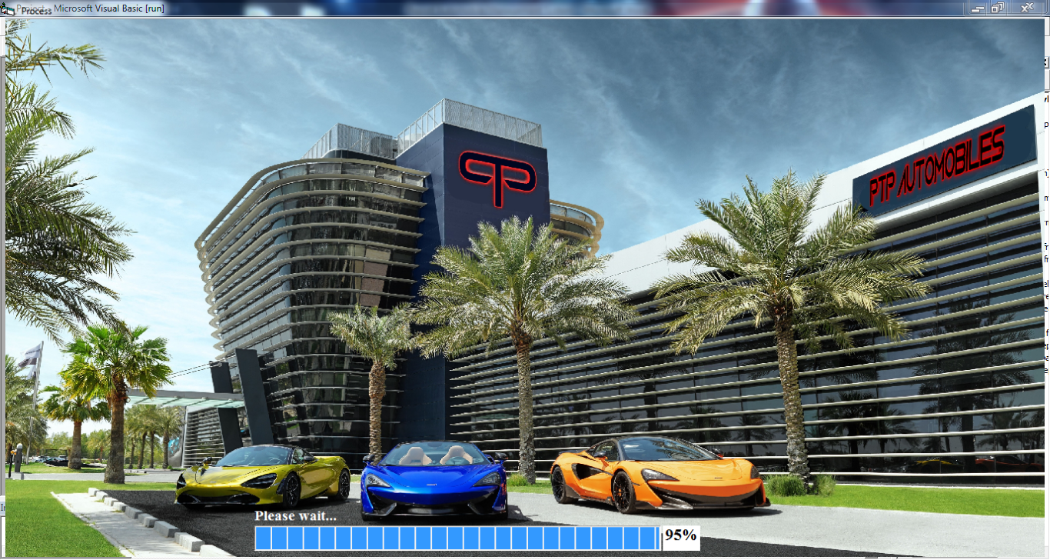

Private Sub Form_Resize()

i1.Height = Me.ScaleHeight

i1.Width = Me.ScaleWidth

End Sub

Private Sub T1_Timer()

T1.Interval = Rnd * 100 + 10

pb1.Value = pb1.Value + 5

L1.Caption = pb1.Value & "%"

If L1.Caption = 100 & "%" Then

Load welcome

welcome.Show

process.Hide

Unload process

End If

End Sub

* + 1. **Welcome Form -**

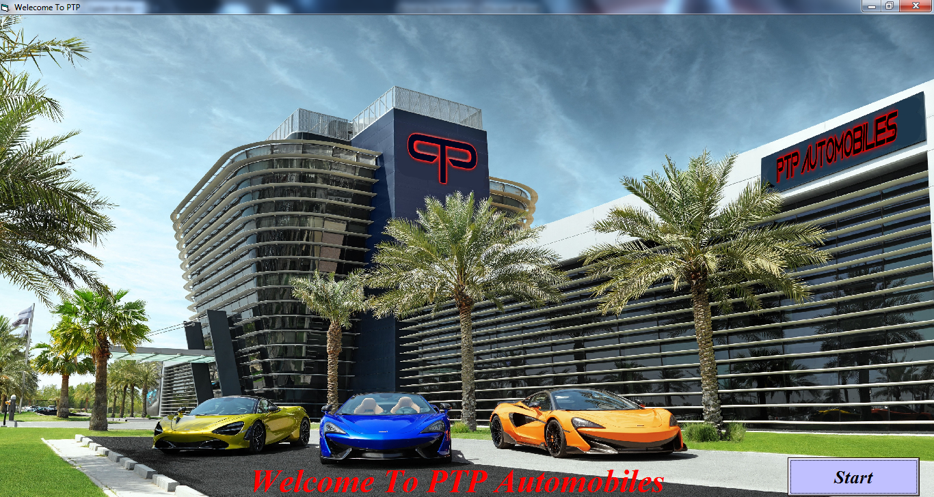

Private Sub Command1_Click()

Load login

login.Show

welcome.Hide

Unload welcome

End Sub

Private Sub Form_Resize()

i1.Height = Me.ScaleHeight

i1.Width = Me.ScaleWidth

End Sub

* + 1. **Login and Remove Account Form -**

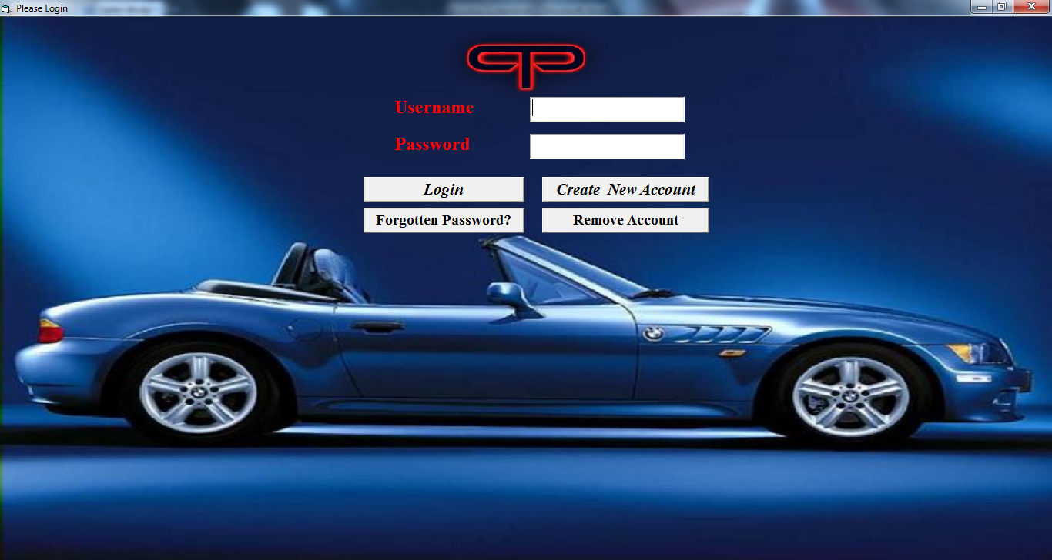

Private Sub cmdForgotPass_Click()

Load forgotpassword

forgotpassword.Show

login.Hide

Unload login

End Sub

Private Sub cmdLogin_Click()

Call closeDB

Call dbconnection5

Dim temp1, temp2 As String

temp1 = txtUsername.Text

temp2 = txtPassword.Text

Set recset = Nothing

recset.Open "select * from Employee where Username = '" & temp1 & "' and Password = '" & temp2 & "'", dbconn, adOpenDynamic, adLockOptimistic

If recset.EOF = True Then

MsgBox "Incorrect Username or Password, Try Again!"

Call closeDB

Exit Sub

Else

Load home

home.Show

login.Hide

Unload login

Call closeDB

Exit Sub

End If

Call closeDB

End Sub

Private Sub cmdNewAccount_Click()

Load singup

singup.Show

login.Hide

Unload login

End Sub

Private Sub cmdRemAccount_Click()

Call closeDB

dbconn.Open "provider=MSDASQL;driver={Mysql odbc 3.51 Driver};database=PTPAutomobiles;server=localhost;user=root;password=123"

recset.Open "select * from Employee where Username = '" & txtUsername.Text & "' And Password = '" & txtPassword.Text & "'", dbconn, adOpenDynamic, adLockOptimistic

If recset.EOF = True Then

MsgBox "RECORD NOT FOUND!!!"

Call closeDB

Exit Sub

Else

ans = MsgBox("Do you want to delete this Record, then click Yes", vbYesNo)

If ans = vbYes Then

recset.Delete

MsgBox "RECORD DELETED..."

Call ClearAll

Call closeDB

Exit Sub

End If

If ans = vbNo Then

recset.Cancel

MsgBox "Your Deletion is Cancelled!!!"

Call closeDB

Exit Sub

End If

End If

End Sub

Private Sub ClearAll()

txtUsername.Text = ""

txtPassword.Text = ""

End Sub

Private Sub Form_Resize()

i1.Width = Me.ScaleWidth

i1.Height = Me.ScaleHeight

End Sub

Private Sub Form_Unload(Cancel As Integer)

Call closeDB

End Sub

* + 1. **Sign-Up Form -**

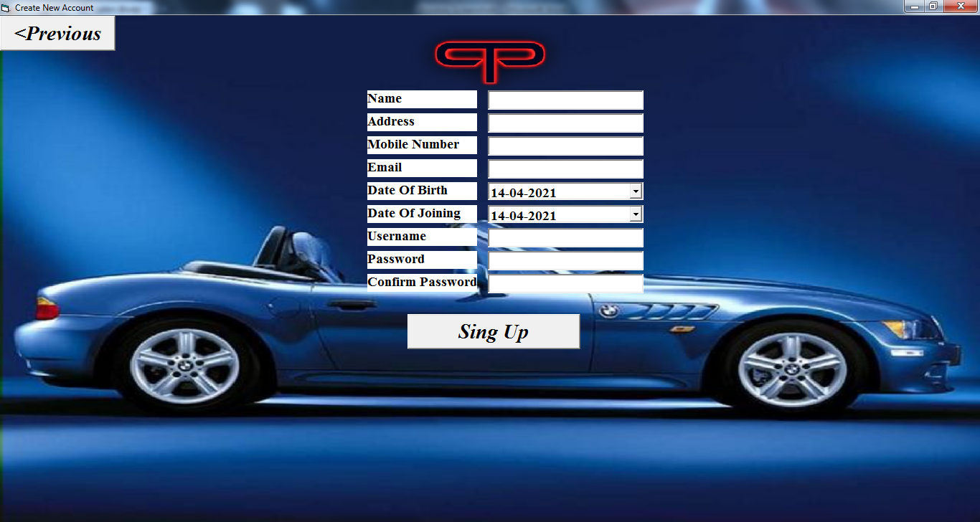

Private Sub cmdPrevious_Click()

Load login

login.Show

singup.Hide

Unload singup

End Sub

Private Sub cmdSignUp_Click()

Call dbconnection5

Dim ans As String

ans = MsgBox("Do you want to Create Account ?, then click Yes", vbYesNo)

If ans = vbYes Then

Dim temp1, temp2 As String

temp1 = txtPass.Text

temp2 = txtConPass.Text

If temp1 = temp2 Then

recset.AddNew

Call updateRecord5

recset.Update

MsgBox "Your Account is Created..."

Call closeDB

Exit Sub

Else

MsgBox "Confirm Password is not same from Original Password"

Call closeDB

Exit Sub

End If

Call closeDB

Exit Sub

End If

If ans = vbNo Then

recset.CancelUpdate

MsgBox "Your Account creation is cancelled!!!"

End If

Call closeDB

End Sub

Private Sub updateRecord5()

recset.Fields("Name").Value = txtName.Text

recset.Fields("Address").Value = txtAddress.Text

recset.Fields("MobileNo").Value = txtMobileNo.Text

recset.Fields("Email").Value = txtEmail.Text

recset.Fields("DOB").Value = dtDOB.Value

recset.Fields("DOJ").Value = dtDOJ.Value

recset.Fields("Username").Value = txtUsername.Text

recset.Fields("Password").Value = txtPass.Text

End Sub

Private Sub txtAddress_Validate(Cancel As Boolean)

If Len(txtAddress.Text) <= 50 Then

Cancel = False

Exit Sub

Else

MsgBox "Address should be atmost 50 Characters!!!"

Cancel = True

Exit Sub

End If

End Sub

Private Sub txtEmail_Validate(Cancel As Boolean)

If Len(txtAddress.Text) <= 50 Then

Cancel = False

Exit Sub

Else

MsgBox "Address should be atmost 50 Characters!!!"

Cancel = True

Exit Sub

End If

End Sub

Private Sub Form_Resize()

i1.Width = Me.ScaleWidth

i1.Height = Me.ScaleHeight

End Sub

Private Sub Form_Unload(Cancel As Integer)

Call closeDB

End Sub

* + 1. **Forgot Password Form -**

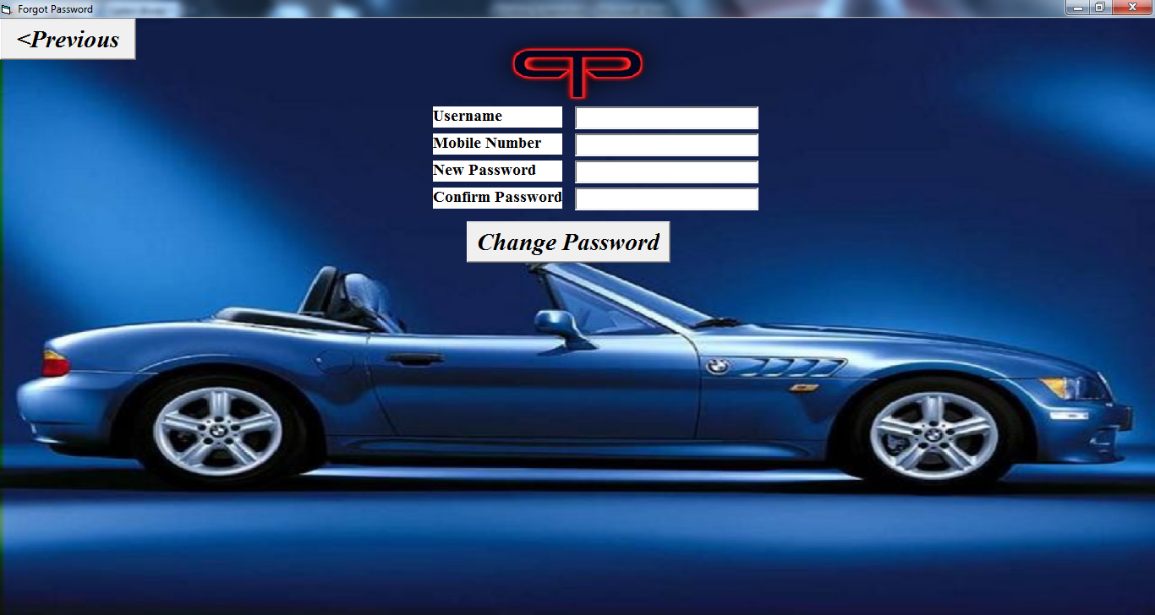

Private Sub cmdback_Click()

Load login

login.Show

forgotpassword.Hide

Unload forgotpassword

End Sub

Private Sub cmdChangePassword_Click()

Call closeDB

Dim ans As String

dbconn.Open "provider=MSDASQL;driver={Mysql odbc 3.51 Driver};database=PTPAutomobiles;server=localhost;user=root;password=123"

recset.Open "select * from Employee where Username = '" & txtUsername.Text & "' And MobileNo = '" & txtMobileNo.Text & "'", dbconn, adOpenDynamic, adLockBatchOptimistic

If recset.EOF = True Then

MsgBox "Username or Mobile Number is Invalid!!!"

Call closeDB

Exit Sub

Else

ans = MsgBox("Do you want to Change Password ?, then click Yes", vbYesNo)

If ans = vbYes Then

If txtNewPass.Text = txtConPass.Text Then

Call changePass

recset.Update

MsgBox "Your Password is Successfully Changed..."

Call ClearAll

Call closeDB

Exit Sub

Else

MsgBox "Your Confirm Password is not matched with New Password!!!"

Call closeDB

Exit Sub

End If

End If

If ans = vbNo Then

recset.CancelUpdate

MsgBox "Password Not Updated!"

Call closeDB

End If

End If

End Sub

Private Sub changePass()

Dim temp As String

temp = txtConPass.Text

recset.Fields("Password").Value = Trim(temp)

End Sub

Private Sub ClearAll()

txtUsername.Text = ""

txtMobileNo.Text = ""

txtNewPass.Text = ""

txtConPass.Text = ""

End Sub

Private Sub Form_Load()

Call dbconnection5

End Sub

Private Sub Form_Resize()

i1.Width = Me.ScaleWidth

i1.Height = Me.ScaleHeight

End Sub

Private Sub Form_Unload(Cancel As Integer)

Call closeDB

End Sub

* + 1. **Home Form -**

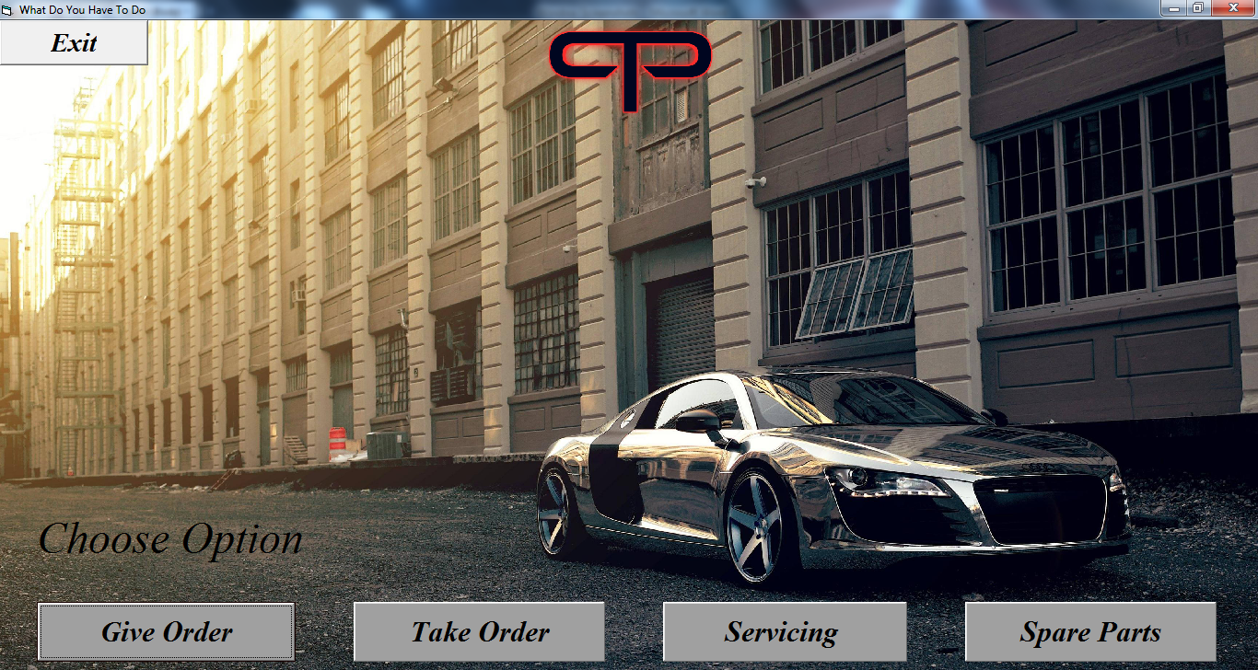

Private Sub cmdExit_Click()

Load welcome

welcome.Show

home.Hide

Unload home

End Sub

Private Sub cmdgive_Click()

Load otm

otm.Show

home.Hide

Unload home

End Sub

Private Sub cmdparts_Click()

Load spareparts

spareparts.Show

home.Hide

Unload home

End Sub

Private Sub cmdservice_Click()

Load service

service.Show

home.Hide

Unload home

End Sub

Private Sub cmdtake_Click()

Load ofc

ofc.Show

home.Hide

Unload home

End Sub

Private Sub Form_Resize()

i1.Height = Me.ScaleHeight

i1.Width = Me.ScaleWidth

End Sub

* + - 1. **Order To Manufacturer Form -**

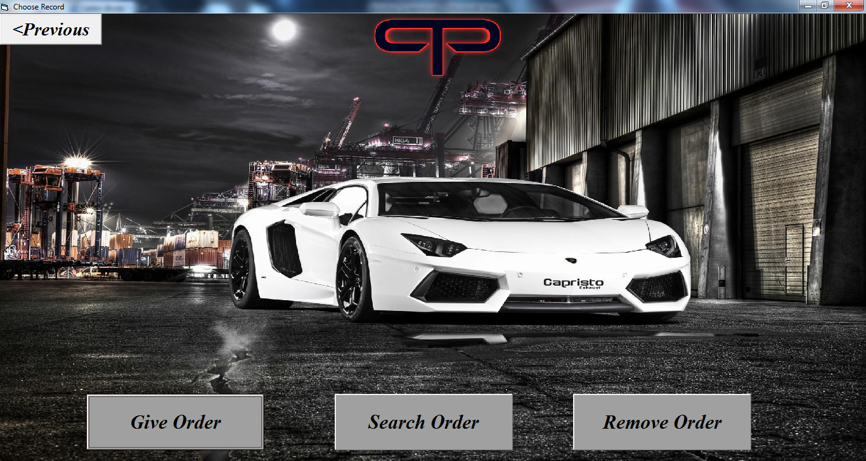

Private Sub cmd1_Click()

Load home

home.Show

otm.Hide

Unload otm

End Sub

Private Sub cmd2_Click()

Load otmsave

otmsave.Show

otm.Hide

Unload otm

End Sub

Private Sub cmd3_Click()

Load otmsearch

otmsearch.Show

otm.Hide

Unload otm

End Sub

Private Sub cmd4_Click()

Load otmdelete

otmdelete.Show

otm.Hide

Unload otm

End Sub

Private Sub Form_Resize()

i1.Width = Me.ScaleWidth

i1.Height = Me.ScaleHeight

End Sub

* + - * 1. **Give Order Form -**

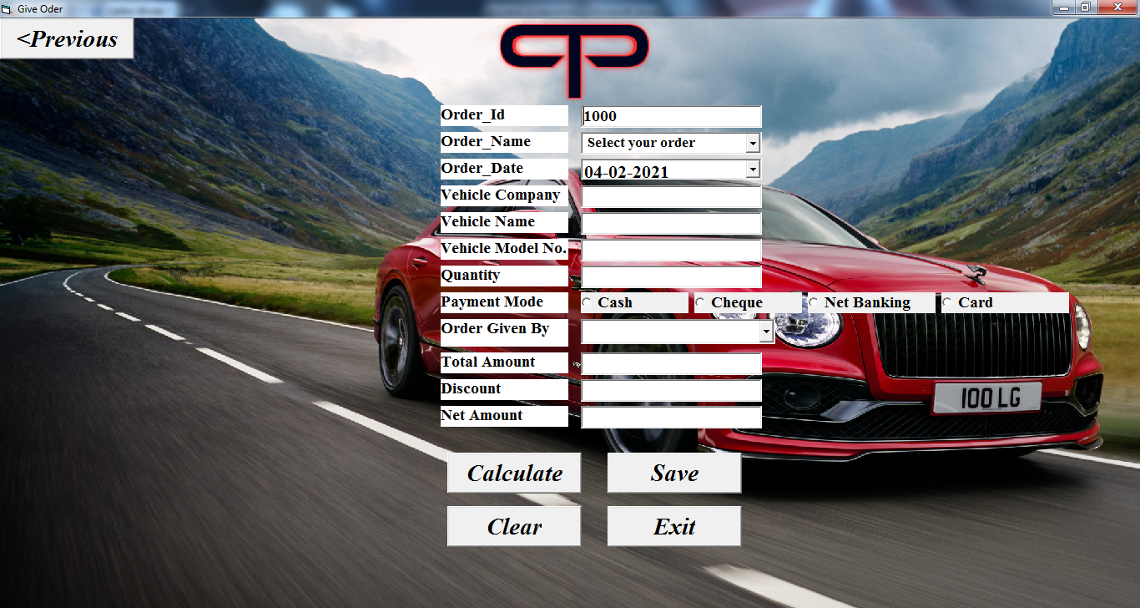

Option Explicit

Dim temp As String

Private Sub cmbOName_Click()

Select Case cmbOName.ListIndex

Case 0

Label13.Visible = False

txtPartName.Visible = False

Case 1

Label13.Visible = True

txtPartName.Visible = True

End Select

End Sub

Private Sub cmdCalculate_Click()

Dim temp As Double

temp = Val(txtTotalAmount.Text * (txtDiscount.Text / 100))

txtNetAmount.Text = Val(txtTotalAmount.Text - temp)

End Sub

Private Sub cmdExit_Click()

Load home

home.Show

otmsave.Hide

Unload otmsave

End Sub

Private Sub cmdPrevious_Click()

Load otm

otm.Show

otmsave.Hide

Unload otmsave

End Sub

Private Sub cmdSave_Click()

Dim ans As String

ans = MsgBox("Do you want to Save this Record, then click Yes", vbYesNo)

If ans = vbYes Then

recset.AddNew

Call updateRecord1

recset.Update

MsgBox "Your record is Saved..."

Call cmdClear_Click

End If

If ans = vbNo Then

recset.CancelUpdate

MsgBox "Your saving is cancelled!!!"

End If

End Sub

Private Sub autoGenerateId()

Call closeDB

Call dbconnection1

If recset.EOF = True Then

txtOId.Text = 1000

Else

recset.MoveLast

txtOId.Text = recset.Fields("Order_Id").Value + 1

End If

End Sub

Private Sub updateRecord1()

recset.Fields("Order_Id").Value = Val(txtOId.Text)

recset.Fields("Order_Name").Value = cmbOName.Text

If txtPartName.Visible = True Then

recset.Fields("Part_Name").Value = txtPartName.Text

Else

recset.Fields("Part_Name").Value = "NULL"

End If

recset.Fields("Order_Date").Value = dtODate.Value

recset.Fields("Vehicle_Company").Value = txtVCompany.Text

recset.Fields("Vehicle_Name").Value = txtVName.Text

recset.Fields("Vehicle_Model_No").Value = txtVModelNo.Text

recset.Fields("Quantity").Value = Val(txtQuantity.Text)

If p1.Value = True Then

recset.Fields("Payment_Mode").Value = p1.Caption

End If

If p2.Value = True Then

recset.Fields("Payment_Mode").Value = p2.Caption

End If

If p3.Value = True Then

recset.Fields("Payment_Mode").Value = p3.Caption

End If

If p4.Value = True Then

recset.Fields("Payment_Mode").Value = p4.Caption

End If

recset.Fields("Order_Given_By").Value = cmbOGivenBy.Text

recset.Fields("Total_Amount").Value = Val(txtTotalAmount.Text)

recset.Fields("Discount").Value = Val(txtDiscount.Text)

recset.Fields("Net_Amount").Value = Val(txtNetAmount)

End Sub

Private Sub cmdClear_Click()

cmbOName.Text = "Select your order"

txtPartName.Text = ""

dtODate.Value = Date

txtVCompany.Text = ""

txtVName.Text = ""

txtVModelNo.Text = ""

txtQuantity.Text = ""

p1.Value = False

p2.Value = False

p3.Value = False

p4.Value = False

cmbOGivenBy.Text = ""

txtTotalAmount.Text = ""

txtDiscount.Text = ""

txtNetAmount.Text = ""

Call autoGenerateId

End Sub

Private Sub addingEmployee()

Call dbconnection5

recset.MoveFirst

Do Until recset.EOF = True

cmbOGivenBy.AddItem recset.Fields("Name").Value

recset.MoveNext

Loop

recset.MoveFirst

Call closeDB

End Sub

Private Sub Form_Resize()

i1.Width = Me.ScaleWidth

i1.Height = Me.ScaleHeight

End Sub

Private Sub Form_Load()

Call addingEmployee

Call dbconnection1

Call autoGenerateId

End Sub

Private Sub Form_Unload(Cancel As Integer)

Call closeDB

End Sub

* + - * 1. **Update Order Form -**

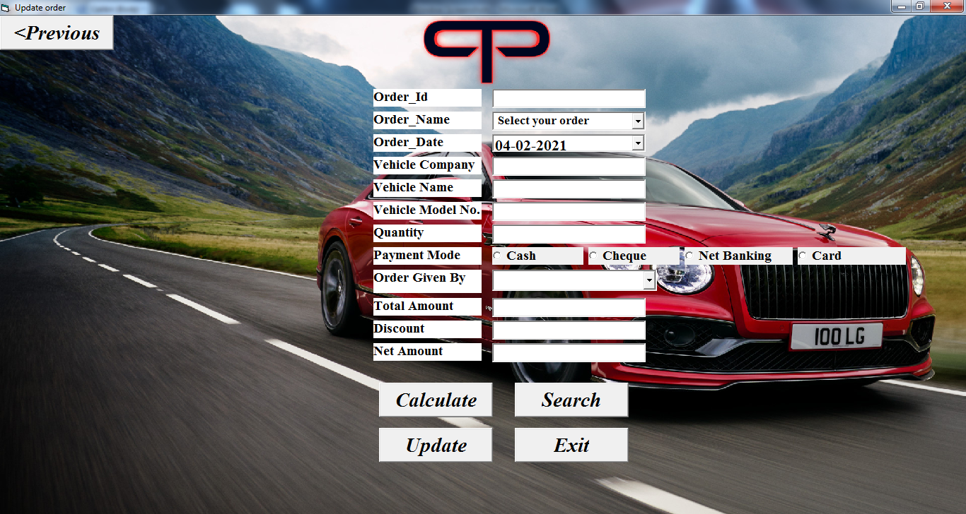

Private Sub cmbOName_Click()

Select Case cmbOName.ListIndex

Case 0

Label13.Visible = False

txtPartName.Visible = False

Case 1

Label13.Visible = True

txtPartName.Visible = True

End Select

End Sub

Private Sub cmdCalculate_Click()

Dim temp As Double

temp = Val(txtTotalAmount.Text * (txtDiscount.Text / 100))

txtNetAmount.Text = Val(txtTotalAmount.Text - temp)

End Sub

Private Sub cmdExit_Click()

Load home

home.Show

otmsearch.Hide

Unload otmsearch

End Sub

Private Sub cmdPrevious_Click()

Load otm

otm.Show

otmsearch.Hide

Unload otmsearch

End Sub

Private Sub cmdSearch_Click()

Call dbconnection1

recset.Close

recset.Open "select * from OrderToManufacturer where Order_Id = '" & txtOId.Text & "'", dbconn, adOpenDynamic, adLockOptimistic

If recset.EOF = True Then

MsgBox "RECORD NOT FOUND!!!"

Else

Call showRecord1

End If

Call closeDB

End Sub

Private Sub cmdUpdate_Click()

dbconn.Open "provider=MSDASQL;driver={Mysql odbc 3.51 Driver};database=PTPAutomobiles;server=localhost;user=root;password=123"

recset.Open "select * from OrderToManufacturer where Order_Id = '" & txtOId.Text & "'", dbconn, adOpenDynamic, adLockOptimistic

Dim ans As String

If recset.EOF = True Then

MsgBox "RECORD NOT FOUND!!!"

Exit Sub

Else

ans = MsgBox("Do you want to Update this Record, then click Yes", vbYesNo)

If ans = vbYes Then

Call updateRecord1

recset.Update

MsgBox "Your record is Updated..."

Call closeDB

Call ClearAll

Exit Sub

End If

If ans = vbNo Then

recset.CancelUpdate

MsgBox "Your Updation is Cancelled!!!"

Call closeDB

Exit Sub

End If

Exit Sub

End If

Call closeDB

End Sub

Private Sub updateRecord1()

'recset.Fields("Order_Id").Value = Val(txtOId.Text)

recset.Fields("Order_Name").Value = cmbOName.Text

If txtPartName.Visible = True Then

recset.Fields("Part_Name").Value = txtPartName.Text

Else

recset.Fields("Part_Name").Value = "NULL"

End If

recset.Fields("Order_Date").Value = dtODate.Value

recset.Fields("Vehicle_Company").Value = txtVCompany.Text

recset.Fields("Vehicle_Name").Value = txtVName.Text

recset.Fields("Vehicle_Model_No").Value = txtVModelNo.Text

recset.Fields("Quantity").Value = Val(txtQuantity.Text)

If p1.Value = True Then

recset.Fields("Payment_Mode").Value = p1.Caption

End If

If p2.Value = True Then

recset.Fields("Payment_Mode").Value = p2.Caption

End If

If p3.Value = True Then

recset.Fields("Payment_Mode").Value = p3.Caption

End If

If p4.Value = True Then

recset.Fields("Payment_Mode").Value = p4.Caption

End If

recset.Fields("Order_Given_By").Value = cmbOGivenBy.Text

recset.Fields("Total_Amount").Value = Val(txtTotalAmount.Text)

recset.Fields("Discount").Value = Val(txtDiscount.Text)

recset.Fields("Net_Amount").Value = Val(txtNetAmount)

End Sub

Private Sub ClearAll()

cmbOName.Text = "Select your order"

txtPartName.Text = ""

dtODate.Value = Date

txtVCompany.Text = ""

txtVName.Text = ""

txtVModelNo.Text = ""

txtQuantity.Text = ""

p1.Value = False

p2.Value = False

p3.Value = False

p4.Value = False

cmbOGivenBy.Text = ""

txtTotalAmount.Text = ""

txtDiscount.Text = ""

txtNetAmount.Text = ""

End Sub

Private Sub showRecord1()

cmbOName.Text = recset.Fields("Order_Name").Value 'for vehicle

If recset.Fields("Order_Name").Value = "Spare Part" Then 'spare part

Label13.Visible = True

txtPartName.Visible = True

txtPartName.Text = recset.Fields("Part_Name").Value

End If

dtODate.Value = recset.Fields("Order_Date").Value

txtVCompany.Text = recset.Fields("Vehicle_Company").Value

txtVName.Text = recset.Fields("Vehicle_Name").Value

txtVModelNo.Text = recset.Fields("Vehicle_Model_No").Value

txtQuantity.Text = recset.Fields("Quantity").Value

If recset.Fields("Payment_Mode").Value = "Cash" Then

p1.Value = True

End If

If recset.Fields("Payment_Mode").Value = "Cheque" Then

p2.Value = True

End If

If recset.Fields("Payment_Mode").Value = "Net Banking" Then

p3.Value = True

End If

If recset.Fields("Payment_Mode").Value = "Card" Then

p4.Value = True

End If

cmbOGivenBy.Text = recset.Fields("Order_Given_By").Value

txtTotalAmount.Text = recset.Fields("Total_Amount").Value

txtDiscount.Text = recset.Fields("Discount").Value

txtNetAmount = recset.Fields("Net_Amount").Value

End Sub

Private Sub addingEmployee()

Call dbconnection5

recset.MoveFirst

Do Until recset.EOF = True

cmbOGivenBy.AddItem recset.Fields("Name").Value

recset.MoveNext

Loop

recset.MoveFirst

Call closeDB

End Sub

Private Sub Form_Load()

Call addingEmployee

End Sub

Private Sub Form_Resize()

i1.Width = Me.ScaleWidth

i1.Height = Me.ScaleHeight

End Sub

Private Sub Form_Unload(Cancel As Integer)

Call closeDB

End Sub

* + - * 1. **Delete Order Form -**

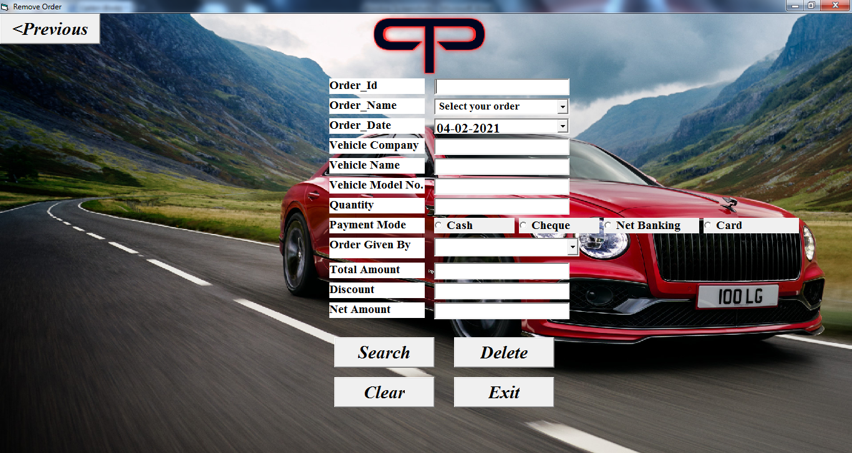

Private Sub cmbOName_Click()

Select Case cmbOName.ListIndex

Case 0

Label13.Visible = False

txtPartName.Visible = False

Case 1

Label13.Visible = True

txtPartName.Visible = True

End Select

End Sub

Private Sub ClearAll()

txtOId.Text = ""

cmbOName.Text = "Select your order"

txtPartName.Text = ""

dtODate.Value = Date

txtVCompany.Text = ""

txtVName.Text = ""

txtVModelNo.Text = ""

txtQuantity.Text = ""

p1.Value = False

p2.Value = False

p3.Value = False

p4.Value = False

cmbOGivenBy.Text = ""

txtTotalAmount.Text = ""

txtDiscount.Text = ""

txtNetAmount.Text = ""

End Sub

Private Sub cmdClear_Click()

Call ClearAll

End Sub

Private Sub cmdDelete_Click()

Call dbconnection1

recset.Close

recset.Open "select * from OrderToManufacturer where Order_Id = '" & txtOId.Text & "'", dbconn, adOpenDynamic, adLockOptimistic

If recset.EOF = True Then

MsgBox "RECORD NOT FOUND!!!"

Call closeDB

Exit Sub

Else

ans = MsgBox("Do you want to delete this Record, then click Yes", vbYesNo)

If ans = vbYes Then

recset.Delete

MsgBox "RECORD DELETED..."

Call ClearAll

Call closeDB

Exit Sub

End If

If ans = vbNo Then

recset.CancelUpdate

MsgBox "Your Deletion is Cancelled!!!"

Call closeDB

Exit Sub

End If

End If

Call closeDB

End Sub

Private Sub cmdExit_Click()

Load home

home.Show

otmdelete.Hide

Unload otmdelete

End Sub

Private Sub cmdPrevious_Click()

Load otm

otm.Show

otmdelete.Hide

Unload otmdelete

End Sub

Private Sub cmdSearch_Click()

Call dbconnection1

recset.Close

recset.Open "select * from OrderToManufacturer where Order_Id = '" & txtOId.Text & "'", dbconn, adOpenDynamic, adLockOptimistic

If recset.EOF = True Then

MsgBox "RECORD NOT FOUND!!!"

Else

Call showRecord1

End If

Call closeDB

End Sub

Private Sub showRecord1()

cmbOName.Text = recset.Fields("Order_Name").Value 'for vehicle

If recset.Fields("Order_Name").Value = "Spare Part" Then 'for spare part

Label13.Visible = True

txtPartName.Visible = True

txtPartName.Text = recset.Fields("Part_Name").Value

End If

dtODate.Value = recset.Fields("Order_Date").Value

txtVCompany.Text = recset.Fields("Vehicle_Company").Value

txtVName.Text = recset.Fields("Vehicle_Name").Value

txtVModelNo.Text = recset.Fields("Vehicle_Model_No").Value

txtQuantity.Text = recset.Fields("Quantity").Value

If recset.Fields("Payment_Mode").Value = "Cash" Then

p1.Value = True

End If

If recset.Fields("Payment_Mode").Value = "Cheque" Then

p2.Value = True

End If

If recset.Fields("Payment_Mode").Value = "Net Banking" Then

p3.Value = True

End If

If recset.Fields("Payment_Mode").Value = "Card" Then

p4.Value = True

End If

cmbOGivenBy.Text = recset.Fields("Order_Given_By").Value

txtTotalAmount.Text = recset.Fields("Total_Amount").Value

txtDiscount.Text = recset.Fields("Discount").Value

txtNetAmount = recset.Fields("Net_Amount").Value

End Sub

Private Sub addingEmployee()

Call dbconnection5

recset.MoveFirst

Do Until recset.EOF = True

cmbOGivenBy.AddItem recset.Fields("Name").Value

recset.MoveNext

Loop

recset.MoveFirst

Call closeDB

End Sub

Private Sub Form_Resize()

i1.Width = Me.ScaleWidth

i1.Height = Me.ScaleHeight

End Sub

Private Sub Form_Load()

Call addingEmployee

End Sub

Private Sub Form_Unload(Cancel As Integer)

Call closeDB

End Sub

* + - 1. **Order From Customer -**

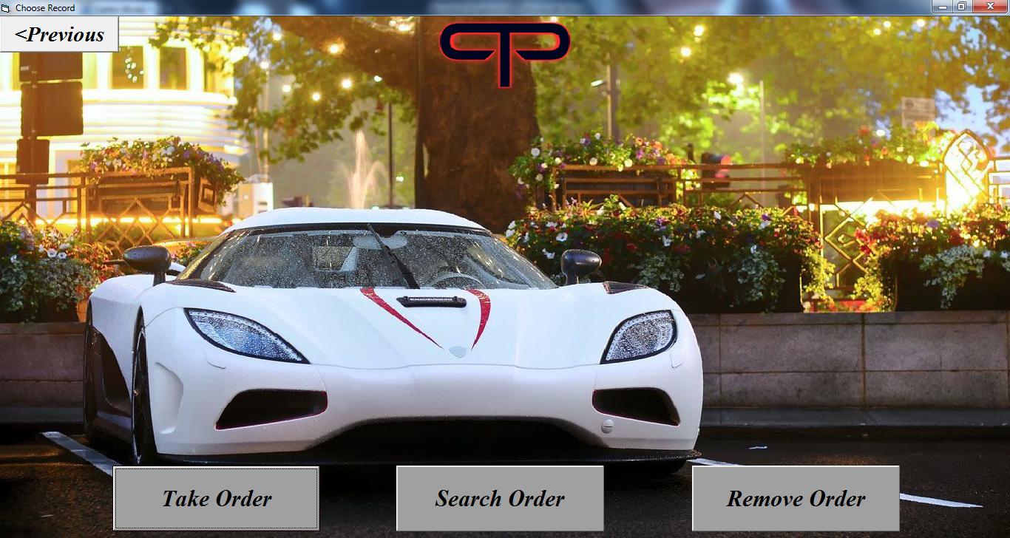

Private Sub cmd1_Click()

Load home

home.Show

ofc.Hide

Unload ofc

End Sub

Private Sub cmd2_Click()

Load ofcsave

ofcsave.Show

ofc.Hide

Unload ofc

End Sub

Private Sub cmd3_Click()

Load ofcsearch

ofcsearch.Show

ofc.Hide

Unload ofc

End Sub

Private Sub cmd4_Click()

Load ofcdelete

ofcdelete.Show

ofc.Hide

Unload ofc

End Sub

Private Sub Form_Resize()

i1.Width = Me.ScaleWidth

i1.Height = Me.ScaleHeight

End Sub

* + - * 1. **Take Order Form -**

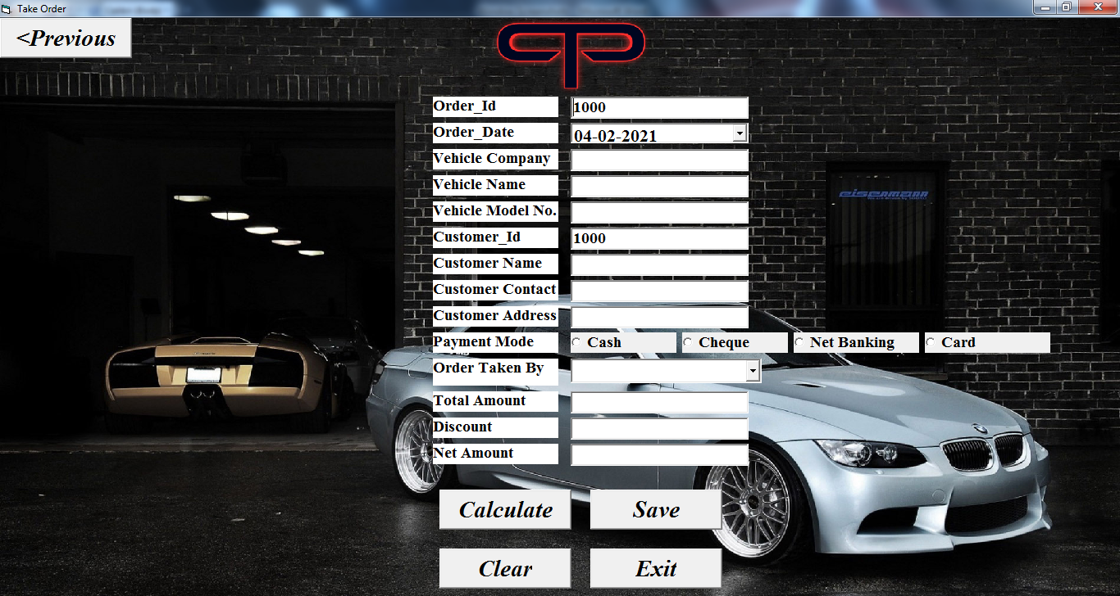

Private Sub cmdCalculate_Click()

Dim temp As Double

temp = Val(txtTotalAmount.Text * (txtDiscount.Text / 100))

txtNetAmount.Text = Val(txtTotalAmount.Text - temp)

End Sub

Private Sub cmdExit_Click()

Load home

home.Show

ofcsave.Hide

Unload ofcsave

End Sub

Private Sub cmdPrevious_Click()

Load ofc

ofc.Show

ofcsave.Hide

Unload ofcsave

End Sub

Private Sub cmdSave_Click()

Dim ans As String

ans = MsgBox("Do you want to Save this Record, then click Yes", vbYesNo)

If ans = vbYes Then

recset.AddNew

Call updateRecord2

recset.Update

MsgBox "Your record is Saved..."

Call cmdClear_Click

End If

If ans = vbNo Then

recset.CancelUpdate

MsgBox "Your saving is cancelled!!!"

End If

End Sub

Private Sub autoGenerateId()

Call closeDB

Call dbconnection2

If recset.BOF = True Or recset.EOF = True Then

txtOId.Text = 1000

txtCustId.Text = 1000

Else

recset.MoveLast

txtOId.Text = recset.Fields("Order_Id").Value + 1

txtCustId.Text = recset.Fields("Customer_Id").Value + 1

End If

End Sub

Private Sub updateRecord2()

recset.Fields("Order_Id").Value = Val(txtOId.Text)

recset.Fields("Order_Date").Value = dtODate.Value

recset.Fields("Vehicle_Company").Value = txtVCompany.Text

recset.Fields("Vehicle_Name").Value = txtVName.Text

recset.Fields("Vehicle_Model_No").Value = txtVModelNo.Text

recset.Fields("Customer_Id").Value = Val(txtCustId.Text)

recset.Fields("Customer_Name").Value = txtCustName.Text

recset.Fields("Customer_Contact").Value = txtCustContact.Text

recset.Fields("Customer_Address").Value = txtCustAddress.Text

If p1.Value = True Then

recset.Fields("Payment_Mode").Value = p1.Caption

End If

If p2.Value = True Then

recset.Fields("Payment_Mode").Value = p2.Caption

End If

If p3.Value = True Then

recset.Fields("Payment_Mode").Value = p3.Caption

End If

If p4.Value = True Then

recset.Fields("Payment_Mode").Value = p4.Caption

End If

recset.Fields("Order_Taken_By").Value = cmbOTakenBy.Text

recset.Fields("Total_Amount").Value = Val(txtTotalAmount.Text)

recset.Fields("Discount").Value = Val(txtDiscount.Text)

recset.Fields("Net_Amount").Value = Val(txtNetAmount)

End Sub

Private Sub cmdClear_Click()

txtOId.Text = ""

dtODate.Value = Date

txtVCompany.Text = ""

txtVName.Text = ""

txtVModelNo.Text = ""

txtCustId.Text = ""

txtCustName.Text = ""

txtCustContact.Text = ""

txtCustAddress.Text = ""

p1.Value = False

p2.Value = False

p3.Value = False

p4.Value = False

cmbOTakenBy.Text = ""

txtTotalAmount.Text = ""

txtDiscount.Text = ""

txtNetAmount.Text = ""

Call autoGenerateId

End Sub

Private Sub addingEmployee()

Call dbconnection5

recset.MoveFirst

Do Until recset.EOF = True

cmbOTakenBy.AddItem recset.Fields("Name").Value

recset.MoveNext

Loop

recset.MoveFirst

Call closeDB

End Sub

Private Sub Form_Load()

Call addingEmployee

Call dbconnection2

Call autoGenerateId

End Sub

Private Sub Form_Unload(Cancel As Integer)

Call closeDB

End Sub

Private Sub Form_Resize()

i1.Width = Me.ScaleWidth

i1.Height = Me.ScaleHeight

End Sub

* + - * 1. **Update Order Form -**

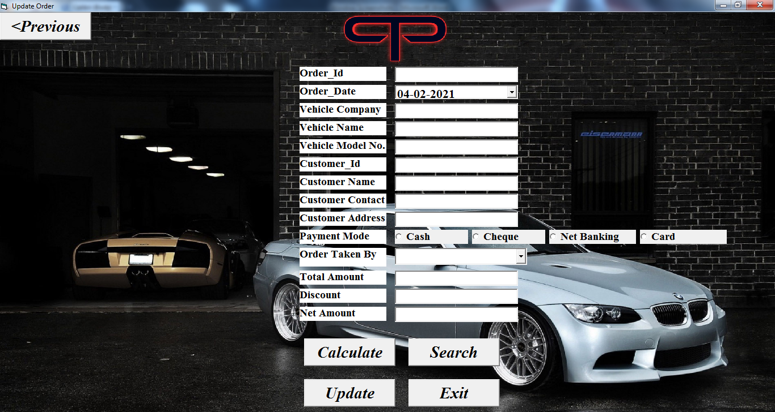

Private Sub cmdCalculate_Click()

Dim temp As Double

temp = Val(txtTotalAmount.Text * (txtDiscount.Text / 100))

txtNetAmount.Text = Val(txtTotalAmount.Text - temp)

End Sub

Private Sub cmdExit_Click()

Load home

home.Show

ofcsearch.Hide

Unload ofcsearch

End Sub

Private Sub cmdPrevious_Click()

Load ofc

ofc.Show

ofcsearch.Hide

Unload ofcsearch

End Sub

Private Sub cmdSearch_Click()

Call dbconnection2

recset.Close

recset.Open "select * from OrderFromCustomer where Order_Id = '" & txtOId.Text & "'", dbconn, adOpenDynamic, adLockOptimistic

If recset.EOF = True Then

MsgBox "RECORD NOT FOUND!!!"

Else

Call showRecord2

End If

Call closeDB

End Sub

Private Sub cmdUpdate_Click()

dbconn.Open "provider=MSDASQL;driver={Mysql odbc 3.51 Driver};database=PTPAutomobiles;server=localhost;user=root;password=123"

recset.Open "select * from OrderFromCustomer where Order_Id = '" & txtOId.Text & "'", dbconn, adOpenDynamic, adLockOptimistic

Dim ans As String

If recset.EOF = True Then

MsgBox "RECORD NOT FOUND!!!"

Exit Sub

Else

ans = MsgBox("Do you want to Update this Record, then click Yes", vbYesNo)

If ans = vbYes Then

Call updateRecord2

recset.Update

MsgBox "Your record is Updated..."

Call closeDB

Call ClearAll

Exit Sub

End If

If ans = vbNo Then

recset.CancelUpdate

MsgBox "Your Updation is Cancelled!!!"

Call closeDB

Exit Sub

End If

Exit Sub

End If

Call closeDB

End Sub

Private Sub showRecord2()

txtOId.Text = recset.Fields("Order_Id").Value

dtODate.Value = recset.Fields("Order_Date").Value

txtVCompany.Text = recset.Fields("Vehicle_Company").Value

txtVName.Text = recset.Fields("Vehicle_Name").Value

txtVModelNo.Text = recset.Fields("Vehicle_Model_No").Value

txtCustId.Text = recset.Fields("Customer_Id").Value

txtCustName.Text = recset.Fields("Customer_Name").Value

txtCustContact.Text = recset.Fields("Customer_Contact").Value

txtCustAddress.Text = recset.Fields("Customer_Address").Value

If recset.Fields("Payment_Mode").Value = "Cash" Then

p1.Value = True

End If

If recset.Fields("Payment_Mode").Value = "Cheque" Then

p2.Value = True

End If

If recset.Fields("Payment_Mode").Value = "Net Banking" Then

p3.Value = True

End If

If recset.Fields("Payment_Mode").Value = "Card" Then

p4.Value = True

End If

cmbOTakenBy.Text = recset.Fields("Order_Taken_By").Value

txtTotalAmount.Text = recset.Fields("Total_Amount").Value

txtDiscount.Text = recset.Fields("Discount").Value

txtNetAmount = recset.Fields("Net_Amount").Value

End Sub

Private Sub addingEmployee()

Call dbconnection5

recset.MoveFirst

Do Until recset.EOF = True

cmbOTakenBy.AddItem recset.Fields("Name").Value

recset.MoveNext

Loop

recset.MoveFirst

Call closeDB

End Sub

Private Sub updateRecord2()

recset.Fields("Order_Id").Value = Val(txtOId.Text)

recset.Fields("Order_Date").Value = dtODate.Value

recset.Fields("Vehicle_Company").Value = txtVCompany.Text

recset.Fields("Vehicle_Name").Value = txtVName.Text

recset.Fields("Vehicle_Model_No").Value = txtVModelNo.Text

recset.Fields("Customer_Id").Value = Val(txtCustId.Text)

recset.Fields("Customer_Name").Value = txtCustName.Text

recset.Fields("Customer_Contact").Value = txtCustContact.Text

recset.Fields("Customer_Address").Value = txtCustAddress.Text

If p1.Value = True Then

recset.Fields("Payment_Mode").Value = p1.Caption

End If

If p2.Value = True Then

recset.Fields("Payment_Mode").Value = p2.Caption

End If

If p3.Value = True Then

recset.Fields("Payment_Mode").Value = p3.Caption

End If

If p4.Value = True Then

recset.Fields("Payment_Mode").Value = p4.Caption

End If

recset.Fields("Order_Taken_By").Value = cmbOTakenBy.Text

recset.Fields("Total_Amount").Value = Val(txtTotalAmount.Text)

recset.Fields("Discount").Value = Val(txtDiscount.Text)

recset.Fields("Net_Amount").Value = Val(txtNetAmount)

End Sub

Private Sub ClearAll()

txtOId.Text = ""

dtODate.Value = Date

txtVCompany.Text = ""

txtVName.Text = ""

txtVModelNo.Text = ""

txtCustId.Text = ""

txtCustName.Text = ""

txtCustContact.Text = ""

txtCustAddress.Text = ""

p1.Value = False

p2.Value = False

p3.Value = False

p4.Value = False

cmbOTakenBy.Text = ""

txtTotalAmount.Text = ""

txtDiscount.Text = ""

txtNetAmount.Text = ""

End Sub

Private Sub Form_Load()

Call addingEmployee

End Sub

Private Sub Form_Resize()

i1.Width = Me.ScaleWidth

i1.Height = Me.ScaleHeight

End Sub

Private Sub Form_Unload(Cancel As Integer)

Call closeDB

End Sub

* + - * 1. **Delete Order Form -**

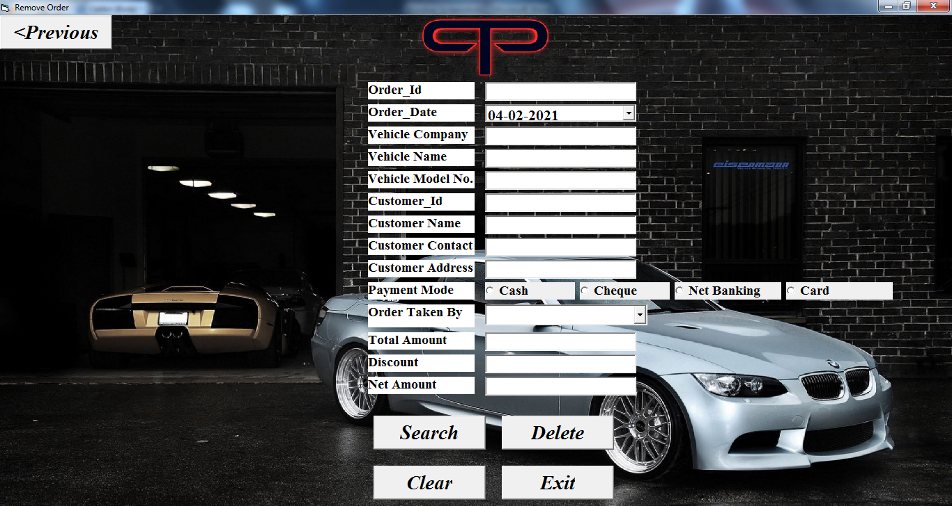

Private Sub cmdClear_Click()

Call ClearAll

End Sub

Private Sub cmdDelete_Click()

Call dbconnection2

recset.Close

recset.Open "select * from OrderFromCustomer where Order_Id = '" & txtOId.Text & "'", dbconn, adOpenDynamic, adLockOptimistic

If recset.EOF = True Then

MsgBox "RECORD NOT FOUND!!!"

Call closeDB

Exit Sub

Else

ans = MsgBox("Do you want to delete this Record, then click Yes", vbYesNo)

If ans = vbYes Then

recset.Delete

MsgBox "RECORD DELETED..."

Call ClearAll

Call closeDB

Exit Sub

End If

If ans = vbNo Then

recset.CancelUpdate

MsgBox "Your Deletion is Cancelled!!!"

Call closeDB

Exit Sub

End If

End If

Call closeDB

End Sub

Private Sub cmdExit_Click()

Load home

home.Show

ofcdelete.Hide

Unload ofcdelete

End Sub

Private Sub cmdPrevious_Click()

Load ofc

ofc.Show

ofcdelete.Hide

Unload ofcdelete

End Sub

Private Sub cmdSearch_Click()

Call dbconnection2

recset.Close

recset.Open "select * from OrderFromCustomer where Order_Id = '" & txtOId.Text & "'", dbconn, adOpenDynamic, adLockOptimistic

If recset.EOF = True Then

MsgBox "RECORD NOT FOUND!!!"

Else

Call showRecord2

End If

Call closeDB

End Sub

Private Sub addingEmployee()

Call dbconnection5

recset.MoveFirst

Do Until recset.EOF = True

cmbOTakenBy.AddItem recset.Fields("Name").Value

recset.MoveNext

Loop

recset.MoveFirst

Call closeDB

End Sub

Private Sub showRecord2()

txtOId.Text = recset.Fields("Order_Id").Value

dtODate.Value = recset.Fields("Order_Date").Value

txtVCompany.Text = recset.Fields("Vehicle_Company").Value

txtVName.Text = recset.Fields("Vehicle_Name").Value

txtVModelNo.Text = recset.Fields("Vehicle_Model_No").Value

txtCustId.Text = recset.Fields("Customer_Id").Value

txtCustName.Text = recset.Fields("Customer_Name").Value

txtCustContact.Text = recset.Fields("Customer_Contact").Value

txtCustAddress.Text = recset.Fields("Customer_Address").Value

If recset.Fields("Payment_Mode").Value = "Cash" Then

p1.Value = True

End If

If recset.Fields("Payment_Mode").Value = "Cheque" Then

p2.Value = True

End If

If recset.Fields("Payment_Mode").Value = "Net Banking" Then

p3.Value = True

End If

If recset.Fields("Payment_Mode").Value = "Card" Then

p4.Value = True

End If

cmbOTakenBy.Text = recset.Fields("Order_Taken_By").Value

txtTotalAmount.Text = recset.Fields("Total_Amount").Value

txtDiscount.Text = recset.Fields("Discount").Value

txtNetAmount = recset.Fields("Net_Amount").Value

End Sub

Private Sub ClearAll()

txtOId.Text = ""

dtODate.Value = Date

txtVCompany.Text = ""

txtVName.Text = ""

txtVModelNo.Text = ""

txtCustId.Text = ""

txtCustName.Text = ""

txtCustContact.Text = ""

txtCustAddress.Text = ""

p1.Value = False

p2.Value = False

p3.Value = False

p4.Value = False

cmbOTakenBy.Text = ""

txtTotalAmount.Text = ""

txtDiscount.Text = ""

txtNetAmount.Text = ""

End Sub

Private Sub Form_Load()

Call addingEmployee

End Sub

Private Sub Form_Resize()

i1.Width = Me.ScaleWidth

i1.Height = Me.ScaleHeight

End Sub

Private Sub Form_Unload(Cancel As Integer)

Call closeDB

End Sub

* + - 1. **Servicing Form -**

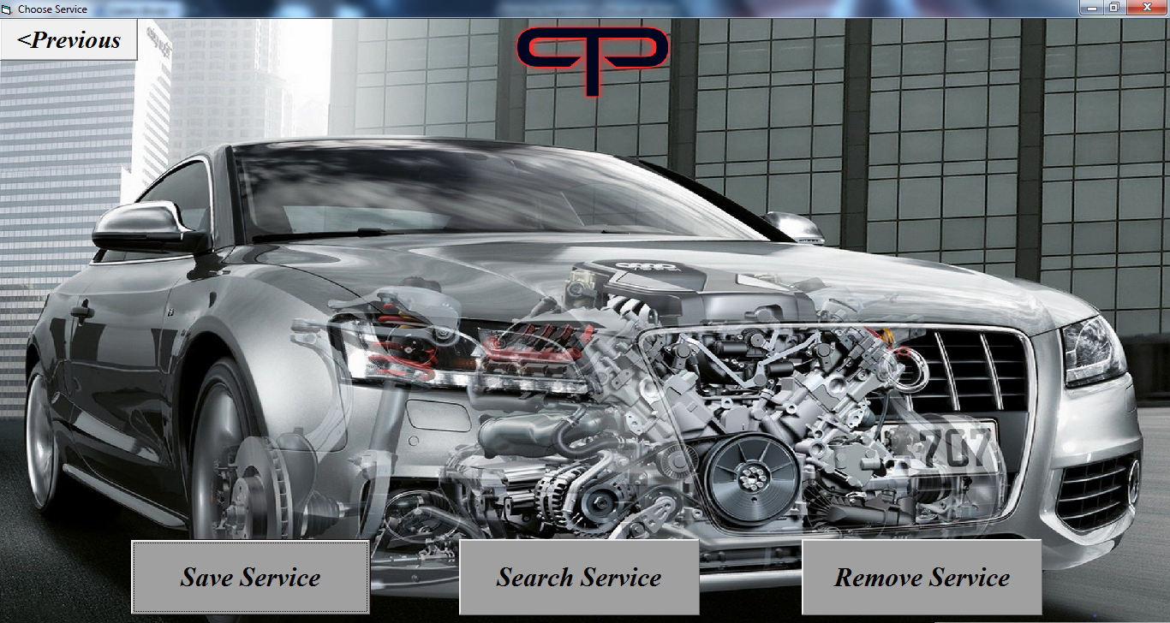

Private Sub cmd1_Click()

Load home

home.Show

service.Hide

Unload service

End Sub

Private Sub cmd2_Click()

Load servicesave

servicesave.Show

service.Hide

Unload service

End Sub

Private Sub cmd3_Click()

Load servicesearch

servicesearch.Show

service.Hide

Unload service

End Sub

Private Sub cmd4_Click()

Load servicedelete

servicedelete.Show

service.Hide

Unload service

End Sub

Private Sub Form_Resize()

i1.Width = Me.ScaleWidth

i1.Height = Me.ScaleHeight

End Sub

* + - * 1. **Save Service Form -**

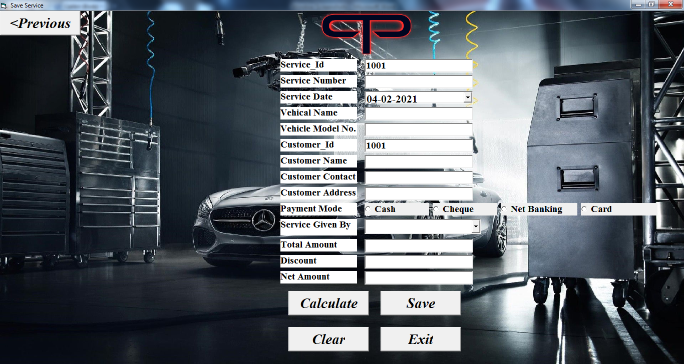

Private Sub cmdCalculate_Click()

Dim temp As Double

temp = Val(txtTotalAmount.Text * (txtDiscount.Text / 100))

txtNetAmount.Text = Val(txtTotalAmount.Text - temp)

End Sub

Private Sub cmdExit_Click()

Load home

home.Show

servicesave.Hide

Unload servicesave

End Sub

Private Sub cmdPrevious_Click()

Load service

service.Show

servicesave.Hide

Unload servicesave

End Sub

Private Sub cmdSave_Click()

Dim ans As String

ans = MsgBox("Do you want to Save this Record, then click Yes", vbYesNo)

If ans = vbYes Then

recset.AddNew

Call updateRecord3

recset.Update

MsgBox "Your record is Saved..."

Call cmdClear_Click

End If

If ans = vbNo Then

recset.CancelUpdate

MsgBox "Your saving is cancelled!!!"

End If

End Sub

Private Sub autoGenerateId()

Call closeDB

Call dbconnection3

If recset.EOF = True Then

txtSId.Text = 1000

txtCustId.Text = 1000

Else

recset.MoveLast

txtSId.Text = recset.Fields("Service_Id").Value + 1

txtCustId.Text = recset.Fields("Customer_Id").Value + 1

End If

End Sub

Private Sub updateRecord3()

recset.Fields("Service_Id").Value = Val(txtSId.Text)

recset.Fields("Service_Number").Value = txtSNo.Text

recset.Fields("Service_Date").Value = dtSDate.Value

recset.Fields("Vehicle_Name").Value = txtVName.Text

recset.Fields("Vehicle_Model_No").Value = txtVModelNo.Text

recset.Fields("Customer_Id").Value = Val(txtCustId.Text)

recset.Fields("Customer_Name").Value = txtCustName.Text

recset.Fields("Customer_Contact").Value = txtCustContact.Text

recset.Fields("Customer_Address").Value = txtCustAddress.Text

If p1.Value = True Then

recset.Fields("Payment_Mode").Value = p1.Caption

End If

If p2.Value = True Then

recset.Fields("Payment_Mode").Value = p2.Caption

End If

If p3.Value = True Then

recset.Fields("Payment_Mode").Value = p3.Caption

End If

If p4.Value = True Then

recset.Fields("Payment_Mode").Value = p4.Caption

End If

recset.Fields("Service_Given_By").Value = cmbSGivenBy.Text

recset.Fields("Total_Amount").Value = Val(txtTotalAmount.Text)

recset.Fields("Discount").Value = Val(txtDiscount.Text)

recset.Fields("Net_Amount").Value = Val(txtNetAmount.Text)

End Sub

Private Sub cmdClear_Click()

txtSId.Text = ""

txtSNo.Text = ""

dtSDate.Value = Date

txtVName.Text = ""

txtVModelNo.Text = ""

txtCustId.Text = ""

txtCustName.Text = ""

txtCustContact.Text = ""

txtCustAddress.Text = ""

p1.Value = False

p2.Value = False

p3.Value = False

p4.Value = False

cmbSGivenBy.Text = ""

txtTotalAmount.Text = ""

txtDiscount.Text = ""

txtNetAmount.Text = ""

Call autoGenerateId

End Sub

Private Sub addingEmployee()

Call dbconnection5

recset.MoveFirst

Do Until recset.EOF = True

cmbSGivenBy.AddItem recset.Fields("Name").Value

recset.MoveNext

Loop

recset.MoveFirst

Call closeDB

End Sub

Private Sub Form_Load()

Call addingEmployee

Call dbconnection3

Call autoGenerateId

End Sub

Private Sub Form_Unload(Cancel As Integer)

Call closeDB

End Sub

Private Sub Form_Resize()

i1.Width = Me.ScaleWidth

i1.Height = Me.ScaleHeight

End Sub

* + - * 1. **Update Service Form -**

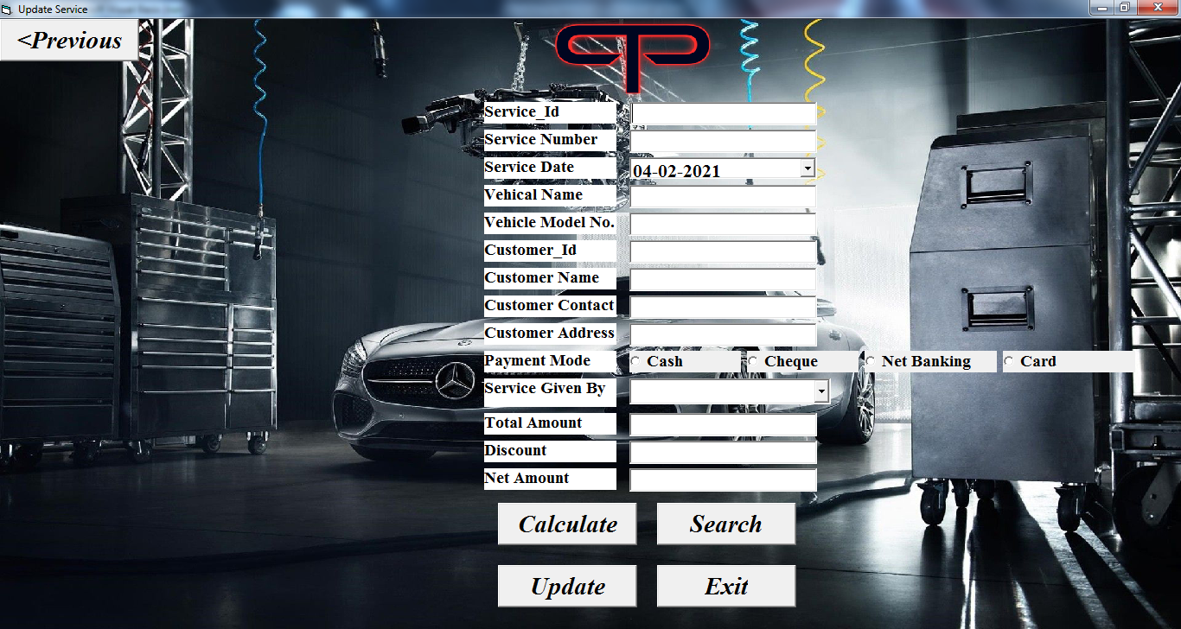

Private Sub cmdCalculate_Click()

Dim temp As Double

temp = Val(txtTotalAmount.Text * (txtDiscount.Text / 100))

txtNetAmount.Text = Val(txtTotalAmount.Text - temp)

End Sub

Private Sub cmdExit_Click()

Load home

home.Show

servicesearch.Hide

Unload servicesearch

End Sub

Private Sub cmdPrevious_Click()

Load service

service.Show

servicesearch.Hide

Unload servicesearch

End Sub

Private Sub cmdSearch_Click()

Call dbconnection3

recset.Close

recset.Open "select * from Servicing where Service_Id = '" & txtSId.Text & "'", dbconn, adOpenDynamic, adLockOptimistic

If recset.EOF = True Then

MsgBox "RECORD NOT FOUND!!!"

Else

Call showRecord3

End If

Call closeDB

End Sub

Private Sub cmdUpdate_Click()

dbconn.Open "provider=MSDASQL;driver={Mysql odbc 3.51 Driver};database=PTPAutomobiles;server=localhost;user=root;password=123"

recset.Open "select * from Servicing where Service_Id = '" & txtSId.Text & "'", dbconn, adOpenDynamic, adLockOptimistic

Dim ans As String

If recset.EOF = True Then

MsgBox "RECORD NOT FOUND!!!"

Exit Sub

Else

ans = MsgBox("Do you want to Update this Record, then click Yes", vbYesNo)

If ans = vbYes Then

Call updateRecord3

recset.Update

MsgBox "Your record is Updated..."

Call closeDB

Call ClearAll

Exit Sub

End If

If ans = vbNo Then

recset.CancelUpdate

MsgBox "Your Updation is Cancelled!!!"

Call closeDB

Exit Sub

End If

Exit Sub

End If

Call closeDB

End Sub

Private Sub showRecord3()

txtSId.Text = recset.Fields("Service_Id").Value

txtSNo.Text = recset.Fields("Service_Number").Value

dtSDate.Value = recset.Fields("Service_Date").Value

txtVName.Text = recset.Fields("Vehicle_Name").Value

txtVModelNo.Text = recset.Fields("Vehicle_Model_No").Value

txtCustId.Text = recset.Fields("Customer_Id").Value

txtCustName.Text = recset.Fields("Customer_Name").Value

txtCustContact.Text = recset.Fields("Customer_Contact").Value

txtCustAddress.Text = recset.Fields("Customer_Address").Value

If recset.Fields("Payment_Mode").Value = "Cash" Then

p1.Value = True

End If

If recset.Fields("Payment_Mode").Value = "Cheque" Then

p2.Value = True

End If

If recset.Fields("Payment_Mode").Value = "Net Banking" Then

p3.Value = True

End If

If recset.Fields("Payment_Mode").Value = "Card" Then

p4.Value = True

End If

cmbSGivenBy.Text = recset.Fields("Service_Given_By").Value

txtTotalAmount.Text = recset.Fields("Total_Amount").Value

txtDiscount.Text = recset.Fields("Discount").Value

txtNetAmount.Text = recset.Fields("Net_Amount").Value

End Sub

Private Sub updateRecord3()

recset.Fields("Service_Id").Value = Val(txtSId.Text)

recset.Fields("Service_Number").Value = txtSNo.Text

recset.Fields("Service_Date").Value = dtSDate.Value

recset.Fields("Vehicle_Name").Value = txtVName.Text

recset.Fields("Vehicle_Model_No").Value = txtVModelNo.Text

recset.Fields("Customer_Id").Value = Val(txtCustId.Text)

recset.Fields("Customer_Name").Value = txtCustName.Text

recset.Fields("Customer_Contact").Value = txtCustContact.Text

recset.Fields("Customer_Address").Value = txtCustAddress.Text

If p1.Value = True Then

recset.Fields("Payment_Mode").Value = p1.Caption

End If

If p2.Value = True Then

recset.Fields("Payment_Mode").Value = p2.Caption

End If

If p3.Value = True Then

recset.Fields("Payment_Mode").Value = p3.Caption

End If

If p4.Value = True Then

recset.Fields("Payment_Mode").Value = p4.Caption

End If

recset.Fields("Service_Given_By").Value = cmbSGivenBy.Text

recset.Fields("Total_Amount").Value = Val(txtTotalAmount.Text)

recset.Fields("Discount").Value = Val(txtDiscount.Text)

recset.Fields("Net_Amount").Value = Val(txtNetAmount.Text)

End Sub

Private Sub addingEmployee()

Call dbconnection5

recset.MoveFirst

Do Until recset.EOF = True

cmbSGivenBy.AddItem recset.Fields("Name").Value

recset.MoveNext

Loop

recset.MoveFirst

Call closeDB

End Sub

Private Sub ClearAll()

txtSId.Text = ""

txtSNo.Text = ""

dtSDate.Value = Date

txtVName.Text = ""

txtVModelNo.Text = ""

txtCustId.Text = ""

txtCustName.Text = ""

txtCustContact.Text = ""

txtCustAddress.Text = ""

p1.Value = False

p2.Value = False

p3.Value = False

p4.Value = False

cmbSGivenBy.Text = ""

txtTotalAmount.Text = ""

txtDiscount.Text = ""

txtNetAmount.Text = ""

End Sub

Private Sub Form_Load()

Call addingEmployee

End Sub

Private Sub Form_Resize()

i1.Width = Me.ScaleWidth

i1.Height = Me.ScaleHeight

End Sub

Private Sub Form_Unload(Cancel As Integer)

Call closeDB

End Sub

* + - * 1. **Delete Service From -**

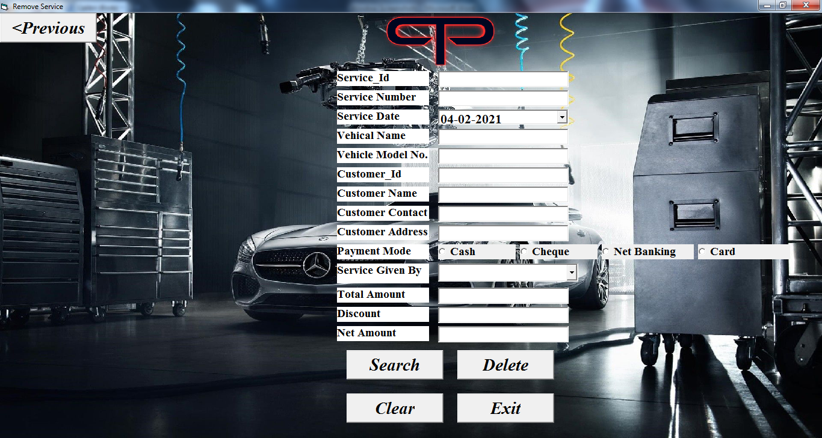

Private Sub cmdClear_Click()

Call ClearAll

End Sub

Private Sub cmdDelete_Click()

Call dbconnection3

recset.Close

recset.Open "select * from Servicing where Service_Id = '" & txtSId.Text & "'", dbconn, adOpenDynamic, adLockOptimistic

If recset.EOF = True Then

MsgBox "RECORD NOT FOUND!!!"

Call closeDB

Exit Sub

Else

ans = MsgBox("Do you want to delete this Record, then click Yes", vbYesNo)

If ans = vbYes Then

recset.Delete

MsgBox "RECORD DELETED..."

Call ClearAll

Call closeDB

Exit Sub

End If

If ans = vbNo Then

recset.CancelUpdate

MsgBox "Your Deletion is Cancelled!!!"

Call closeDB

Exit Sub

End If

End If

Call closeDB

End Sub

Private Sub cmdExit_Click()

Load home

home.Show

servicedelete.Hide

Unload servicedelete

End Sub

Private Sub cmdPrevious_Click()

Load service

service.Show

servicedelete.Hide

Unload servicedelete

End Sub

Private Sub cmdSearch_Click()

Call dbconnection3

recset.Close

recset.Open "select * from Servicing where Service_Id = '" & txtSId.Text & "'", dbconn, adOpenDynamic, adLockOptimistic

If recset.EOF = True Then

MsgBox "RECORD NOT FOUND!!!"

Else

Call showRecord3

End If

Call closeDB

End Sub

Private Sub showRecord3()

txtSId.Text = recset.Fields("Service_Id").Value

txtSNo.Text = recset.Fields("Service_Number").Value

dtSDate.Value = recset.Fields("Service_Date").Value

txtVName.Text = recset.Fields("Vehicle_Name").Value

txtVModelNo.Text = recset.Fields("Vehicle_Model_No").Value

txtCustId.Text = recset.Fields("Customer_Id").Value

txtCustName.Text = recset.Fields("Customer_Name").Value

txtCustContact.Text = recset.Fields("Customer_Contact").Value

txtCustAddress.Text = recset.Fields("Customer_Address").Value

If recset.Fields("Payment_Mode").Value = "Cash" Then

p1.Value = True

End If

If recset.Fields("Payment_Mode").Value = "Cheque" Then

p2.Value = True

End If

If recset.Fields("Payment_Mode").Value = "Net Banking" Then

p3.Value = True

End If

If recset.Fields("Payment_Mode").Value = "Card" Then

p4.Value = True

End If

cmbSGivenBy.Text = recset.Fields("Service_Given_By").Value

txtTotalAmount.Text = recset.Fields("Total_Amount").Value

txtDiscount.Text = recset.Fields("Discount").Value

txtNetAmount = recset.Fields("Net_Amount").Value

End Sub

Private Sub addingEmployee()

Call dbconnection5

recset.MoveFirst

Do Until recset.EOF = True

cmbSGivenBy.AddItem recset.Fields("Name").Value

recset.MoveNext

Loop

recset.MoveFirst

Call closeDB

End Sub

Private Sub ClearAll()

txtSId.Text = ""

txtSNo.Text = ""

dtSDate.Value = Date

txtVName.Text = ""

txtVModelNo.Text = ""

txtCustId.Text = ""

txtCustName.Text = ""

txtCustContact.Text = ""

txtCustAddress.Text = ""

p1.Value = False

p2.Value = False

p3.Value = False

p4.Value = False

cmbSGivenBy.Text = ""

txtTotalAmount.Text = ""

txtDiscount.Text = ""

txtNetAmount.Text = ""

End Sub

Private Sub Form_Load()

Call addingEmployee

End Sub

Private Sub Form_Resize()

i1.Width = Me.ScaleWidth

i1.Height = Me.ScaleHeight

End Sub

Private Sub Form_Unload(Cancel As Integer)

Call closeDB

End Sub

* + - 1. **Spare Parts Form -**

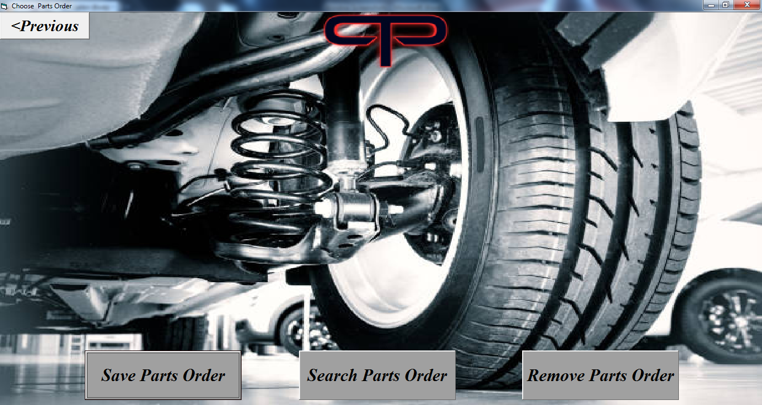

Private Sub cmd1_Click()

Load home

home.Show

spareparts.Hide

Unload spareparts

End Sub

Private Sub cmd2_Click()

Load sparepartssave

sparepartssave.Show

spareparts.Hide

Unload spareparts

End Sub

Private Sub cmd3_Click()

Load sparepartssearch

sparepartssearch.Show

spareparts.Hide

Unload spareparts

End Sub

Private Sub cmd4_Click()

Load sparepartsdelete

sparepartsdelete.Show

spareparts.Hide

Unload spareparts

End Sub

Private Sub Form_Resize()

i1.Width = Me.ScaleWidth

i1.Height = Me.ScaleHeight

End Sub

* + - * 1. **Save Spare Parts Form -**

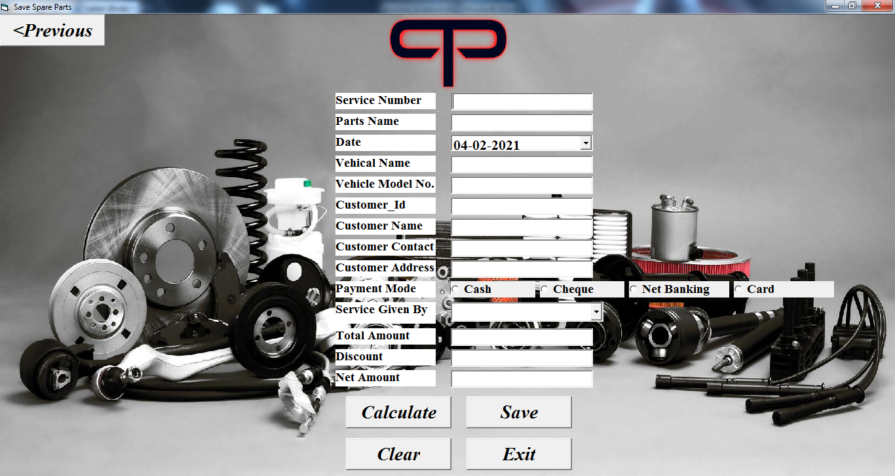

Private Sub cmdCalculate_Click()

Dim temp As Double

temp = Val(txtTotalAmount.Text * (txtDiscount.Text / 100))

txtNetAmount.Text = Val(txtTotalAmount.Text - temp)

End Sub

Private Sub cmdExit_Click()

Load home

home.Show

sparepartssave.Hide

Unload sparepartssave

End Sub

Private Sub cmdPrevious_Click()

Call closeDB

Load spareparts

spareparts.Show

sparepartssave.Hide

Unload sparepartssave

End Sub

Private Sub cmdSave_Click()

Call dbconnection4

Dim ans As String

ans = MsgBox("Do you want to Save this Record, then click Yes", vbYesNo)

If ans = vbYes Then

recset.AddNew

Call updateRecord4

recset.Update

MsgBox "Your record is Saved..."

Call cmdClear_Click

End If

If ans = vbNo Then

recset.CancelUpdate

MsgBox "Your saving is cancelled!!!"

End If

Call closeDB

End Sub

Private Sub updateRecord4()

recset.Fields("Service_Number").Value = txtSNo.Text

recset.Fields("Parts_Name").Value = txtPartsName.Text

recset.Fields("Date").Value = dtDate.Value

recset.Fields("Vehicle_Name").Value = txtVName.Text

recset.Fields("Vehicle_Model_No").Value = txtVModelNo.Text

recset.Fields("Customer_Id").Value = Val(txtCustId.Text)

recset.Fields("Customer_Name").Value = txtCustName.Text

recset.Fields("Customer_Contact").Value = txtCustContact.Text

recset.Fields("Customer_Address").Value = txtCustAddress.Text

If p1.Value = True Then

recset.Fields("Payment_Mode").Value = p1.Caption

End If

If p2.Value = True Then

recset.Fields("Payment_Mode").Value = p2.Caption

End If

If p3.Value = True Then

recset.Fields("Payment_Mode").Value = p3.Caption

End If

If p4.Value = True Then

recset.Fields("Payment_Mode").Value = p4.Caption

End If

recset.Fields("Service_Given_By").Value = cmbSGivenBy.Text

recset.Fields("Total_Amount").Value = Val(txtTotalAmount.Text)

recset.Fields("Discount").Value = Val(txtDiscount.Text)

recset.Fields("Net_Amount").Value = Val(txtNetAmount.Text)

End Sub

Private Sub showRecord4()

Call closeDB

Call dbconnection3

recset.Close

On Error GoTo lbl

recset.Open "select * from Servicing where Service_Number = '" & txtSNo.Text & "'", dbconn, adOpenDynamic, adLockOptimistic

dtDate.Value = recset.Fields("Service_Date").Value

txtVName.Text = recset.Fields("Vehicle_Name").Value

txtVModelNo.Text = recset.Fields("Vehicle_Model_No").Value

txtCustId.Text = recset.Fields("Customer_Id").Value

txtCustName.Text = recset.Fields("Customer_Name").Value

txtCustContact.Text = recset.Fields("Customer_Contact").Value

txtCustAddress.Text = recset.Fields("Customer_Address").Value

If recset.Fields("Payment_Mode").Value = "Cash" Then

p1.Value = True

End If

If recset.Fields("Payment_Mode").Value = "Cheque" Then

p2.Value = True

End If

If recset.Fields("Payment_Mode").Value = "Net Banking" Then

p3.Value = True

End If

If recset.Fields("Payment_Mode").Value = "Card" Then

p4.Value = True

End If

cmbSGivenBy.Text = recset.Fields("Service_Given_By").Value

txtTotalAmount.Text = recset.Fields("Total_Amount").Value

txtDiscount.Text = recset.Fields("Discount").Value

txtNetAmount.Text = recset.Fields("Net_Amount").Value

Call closeDB

Exit Sub

lbl:

MsgBox "Record Not Found!!!"

Call closeDB

Exit Sub

End Sub

Private Sub cmdClear_Click()

txtSNo.Text = ""

txtPartsName.Text = ""

dtDate.Value = Date

txtVName.Text = ""

txtVModelNo.Text = ""

txtCustId.Text = ""

txtCustName.Text = ""

txtCustContact.Text = ""

txtCustAddress.Text = ""

p1.Value = False

p2.Value = False

p3.Value = False

p4.Value = False

cmbSGivenBy.Text = ""

txtTotalAmount.Text = ""

txtDiscount.Text = ""

txtNetAmount.Text = ""

End Sub

Private Sub txtSNo_LostFocus()

Call showRecord4

End Sub

Private Sub addingEmployee()

Call dbconnection5

recset.MoveFirst

Do Until recset.EOF = True

cmbSGivenBy.AddItem recset.Fields("Name").Value

recset.MoveNext

Loop

recset.MoveFirst

Call closeDB

End Sub

Private Sub Form_Load()

Call addingEmployee

Call dbconnection4

End Sub

Private Sub Form_Resize()

i1.Width = Me.ScaleWidth

i1.Height = Me.ScaleHeight

End Sub

Private Sub Form_Unload(Cancel As Integer)

Call closeDB

End Sub

* + - * 1. **Update Spare Parts Form -**

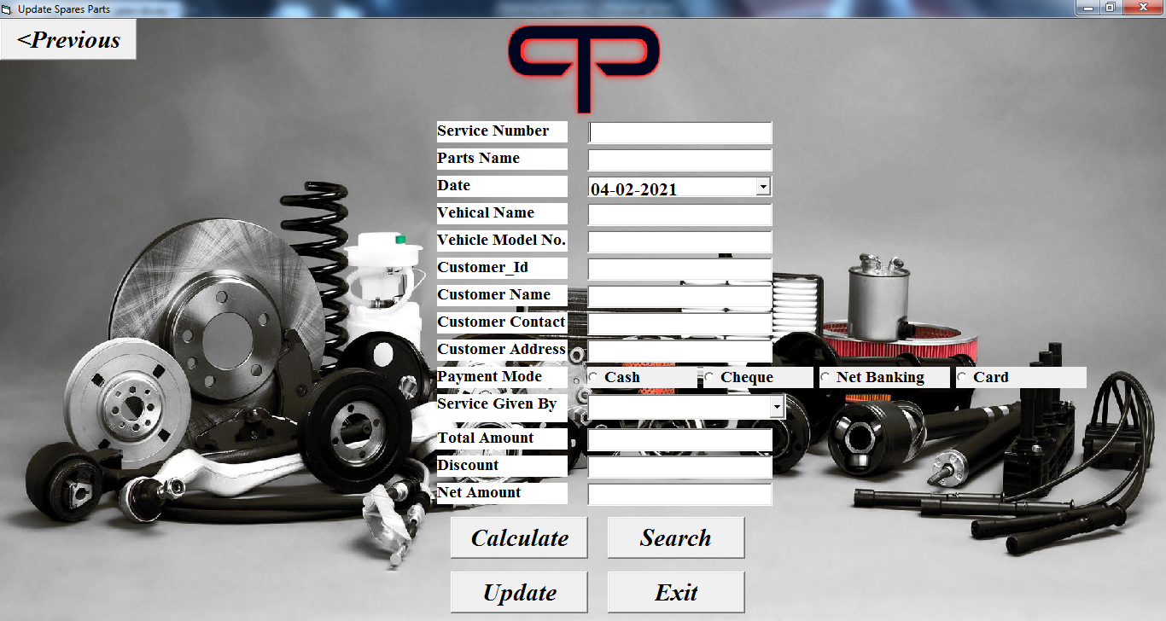

Private Sub cmdCaluculate_Click()

Dim temp As Double

temp = Val(txtTotalAmount.Text * (txtDiscount.Text / 100))

txtNetAmount.Text = Val(txtTotalAmount.Text - temp)

End Sub

Private Sub cmdExit_Click()

Load home

home.Show

sparepartssearch.Hide

Unload sparepartssearch

End Sub

Private Sub cmdPrevious_Click()

Load spareparts

spareparts.Show

sparepartssearch.Hide

Unload sparepartssearch

End Sub

Private Sub cmdSearch_Click()

Call closeDB

dbconn.Open "provider=MSDASQL;driver={Mysql ODBC 3.51 Driver};database=PTPAutomobiles;server=localhost;user=root;password=123"

recset.Open "select * from SpareParts where Service_Number = '" & txtSNo.Text & "'", dbconn, adOpenDynamic, adLockOptimistic

If recset.EOF = True Then

MsgBox "RECORD NOT FOUND!!!"

Call closeDB

Exit Sub

Else

Call showRecord4

Call closeDB

Exit Sub

End If

Call closeDB

End Sub

Private Sub cmdUpdate_Click()

Call closeDB

dbconn.Open "provider=MSDASQL;driver={Mysql ODBC 3.51 Driver};database=PTPAutomobiles;server=localhost;user=root;password=123"

recset.Open "select * from SpareParts where Service_Number = '" & txtSNo.Text & "'", dbconn, adOpenDynamic, adLockOptimistic

Dim ans As String

If recset.EOF = True Then

MsgBox "RECORD NOT FOUND!!!"

Call closeDB

Exit Sub

Else

ans = MsgBox("Do you want to Update this Record, then click Yes", vbYesNo)

If ans = vbYes Then

Call updateRecord4

recset.Update

MsgBox "Your record is Updated..."

Call closeDB

Call ClearAll

Exit Sub

End If

If ans = vbNo Then

recset.CancelUpdate

MsgBox "Your Updation is Cancelled!!!"

Call closeDB

Exit Sub

End If

Exit Sub

End If

Call closeDB

End Sub

Private Sub showRecord4()

txtPartsName.Text = recset.Fields("Parts_Name").Value

dtDate.Value = recset.Fields("Date").Value

txtVName.Text = recset.Fields("Vehicle_Name").Value

txtVModelNo.Text = recset.Fields("Vehicle_Model_No").Value

txtCustId.Text = recset.Fields("Customer_Id").Value

txtCustName.Text = recset.Fields("Customer_Name").Value

txtCustContact.Text = recset.Fields("Customer_Contact").Value

txtCustAddress.Text = recset.Fields("Customer_Address").Value

If recset.Fields("Payment_Mode").Value = "Cash" Then

p1.Value = True

End If

If recset.Fields("Payment_Mode").Value = "Cheque" Then

p2.Value = True

End If

If recset.Fields("Payment_Mode").Value = "Net Banking" Then

p3.Value = True

End If

If recset.Fields("Payment_Mode").Value = "Card" Then

p4.Value = True

End If

cmbSGivenBy.Text = recset.Fields("Service_Given_By").Value

txtTotalAmount.Text = recset.Fields("Total_Amount").Value

txtDiscount.Text = recset.Fields("Discount").Value

txtNetAmount.Text = recset.Fields("Net_Amount").Value

End Sub

Private Sub updateRecord4()

recset.Fields("Parts_Name").Value = txtPartsName.Text

recset.Fields("Date").Value = dtDate.Value

recset.Fields("Vehicle_Name").Value = txtVName.Text

recset.Fields("Vehicle_Model_No").Value = txtVModelNo.Text

recset.Fields("Customer_Id").Value = Val(txtCustId.Text)

recset.Fields("Customer_Name").Value = txtCustName.Text

recset.Fields("Customer_Contact").Value = txtCustContact.Text

recset.Fields("Customer_Address").Value = txtCustAddress.Text

If p1.Value = True Then

recset.Fields("Payment_Mode").Value = p1.Caption

End If

If p2.Value = True Then

recset.Fields("Payment_Mode").Value = p2.Caption

End If

If p3.Value = True Then

recset.Fields("Payment_Mode").Value = p3.Caption

End If

If p4.Value = True Then

recset.Fields("Payment_Mode").Value = p4.Caption

End If

recset.Fields("Service_Given_By").Value = cmbSGivenBy.Text

recset.Fields("Total_Amount").Value = Val(txtTotalAmount.Text)

recset.Fields("Discount").Value = Val(txtDiscount.Text)

recset.Fields("Net_Amount").Value = Val(txtNetAmount.Text)

End Sub

Private Sub ClearAll()

txtSNo.Text = ""

txtPartsName.Text = ""

dtDate.Value = Date

txtVName.Text = ""

txtVModelNo.Text = ""

txtCustId.Text = ""

txtCustName.Text = ""

txtCustContact.Text = ""

txtCustAddress.Text = ""

p1.Value = False

p2.Value = False

p3.Value = False

p4.Value = False

cmbSGivenBy.Text = ""

txtTotalAmount.Text = ""

txtDiscount.Text = ""

txtNetAmount.Text = ""

End Sub

Private Sub addingEmployee()

Call dbconnection5

recset.MoveFirst

Do Until recset.EOF = True

cmbSGivenBy.AddItem recset.Fields("Name").Value

recset.MoveNext

Loop

recset.MoveFirst

Call closeDB

End Sub

Private Sub Form_Load()

Call addingEmployee

Call closeDB

End Sub

Private Sub Form_Resize()

i1.Width = Me.ScaleWidth

i1.Height = Me.ScaleHeight

End Sub

Private Sub Form_Unload(Cancel As Integer)

Call closeDB

End Sub

* + - * 1. **Delete Spare Parts Form -**

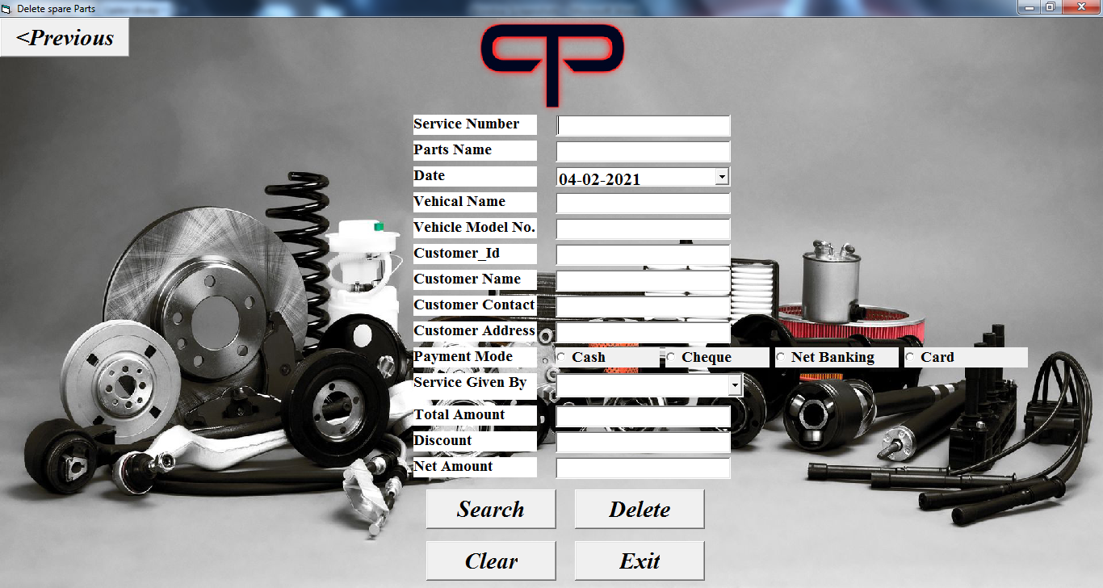

Private Sub cmbPevious_Click()

Load spareparts

spareparts.Show

sparepartsdelete.Hide

Unload sparepartsdelete

End Sub

Private Sub cmdClear_Click()

Call ClearAll

End Sub

Private Sub cmdDelete_Click()

Call dbconnection4

recset.Close

recset.Open "select * from SpareParts where Service_Number = '" & txtSNo.Text & "'", dbconn, adOpenDynamic, adLockOptimistic

If recset.EOF = True Then

MsgBox "RECORD NOT FOUND!!!"

Call closeDB

Exit Sub

Else

ans = MsgBox("Do you want to delete this Record, then click Yes", vbYesNo)

If ans = vbYes Then

recset.Delete

MsgBox "RECORD DELETED..."

Call ClearAll

Call closeDB

Exit Sub

End If

If ans = vbNo Then

recset.CancelUpdate

MsgBox "Your Deletion is Cancelled!!!"

Call closeDB

Exit Sub

End If

End If

Call closeDB

End Sub

Private Sub cmdExit_Click()

Load home

home.Show

sparepartsdelete.Hide

Unload sparepartsdelete

End Sub

Private Sub cmdSearch_Click()

Call dbconnection4

recset.Close

recset.Open "select * from SpareParts where Service_Number = '" & txtSNo.Text & "'", dbconn, adOpenDynamic, adLockOptimistic

If recset.EOF = True Then

MsgBox "RECORD NOT FOUND!!!"

Else

Call showRecord4

End If

Call closeDB

End Sub

Private Sub showRecord4()

txtPartsName.Text = recset.Fields("Parts_Name").Value

dtDate.Value = recset.Fields("Date").Value

txtVName.Text = recset.Fields("Vehicle_Name").Value

txtVModelNo.Text = recset.Fields("Vehicle_Model_No").Value

txtCustId.Text = recset.Fields("Customer_Id").Value

txtCustName.Text = recset.Fields("Customer_Name").Value

txtCustContact.Text = recset.Fields("Customer_Contact").Value

txtCustAddress.Text = recset.Fields("Customer_Address").Value

If recset.Fields("Payment_Mode").Value = "Cash" Then

p1.Value = True

End If

If recset.Fields("Payment_Mode").Value = "Cheque" Then

p2.Value = True

End If

If recset.Fields("Payment_Mode").Value = "Net Banking" Then

p3.Value = True

End If

If recset.Fields("Payment_Mode").Value = "Cash" Then

p4.Value = True

End If

cmbSGivenBy.Text = recset.Fields("Service_Given_By").Value

txtTotalAmount.Text = recset.Fields("Total_Amount").Value

txtDiscount.Text = recset.Fields("Discount").Value

txtNetAmount.Text = recset.Fields("Net_Amount").Value

End Sub

Private Sub addingEmployee()

Call dbconnection5

recset.MoveFirst

Do Until recset.EOF = True

cmbSGivenBy.AddItem recset.Fields("Name").Value

recset.MoveNext

Loop

recset.MoveFirst

Call closeDB

End Sub

Private Sub ClearAll()

txtSNo.Text = ""

txtPartsName.Text = ""

dtDate.Value = Date

txtVName.Text = ""

txtVModelNo.Text = ""

txtCustId.Text = ""

txtCustName.Text = ""

txtCustContact.Text = ""

txtCustAddress.Text = ""

p1.Value = False

p2.Value = False

p3.Value = False

p4.Value = False

cmbSGivenBy.Text = ""

txtTotalAmount.Text = ""

txtDiscount.Text = ""

txtNetAmount.Text = ""

End Sub

Private Sub Form_Load()

Call addingEmployee

End Sub

Private Sub Form_Resize()

i1.Width = Me.ScaleWidth

i1.Height = Me.ScaleHeight

End Sub

Private Sub Form_Unload(Cancel As Integer)

Call closeDB

End Sub

* 1. **Input Specification**

Input is any data instruction entered into the memory of a computer.

Two types of input are - Data and Instruction.

Data is a collection of unorganized items that can include words, numbers and alphanumeric. A computer processes data into information which is organized, meaningful and useful.

Instruction can be in the form of programs, commands or user responses.

A program is a series of instructions that tells a computer how to perform the task necessary to process the data into information.

A command is an instruction given to a computer program.

Inputs of PTP Automobiles are Username, Order Id, Customer Id, Cutomer Name, Vehicle Name and etc.

* 1. **Output Specification**

Output may occur to database or file for storing information entered or also for use by other systems. Output is data that has been processed into a useful form called information.

Output specification involves specifying how orders of on-screen report and paper based reports will occur.

Two types of output are - Text and Graphics.

Text consist of alphanumeric values or characters that are used to create words senctences and paragraphs.

Graphics are digital representation of non-text information, such as charts, 3D models and animations. An output device is any computer component capable of conveying information to the user (like - Monitors).

1. Conclusion

The system is completely option driven and user friendly, since it is developed in an efficient frontend tool VB (Visual Basic). Appropriate error message are also provide to guide the user in a proper and user friendly manner.

The software “PTP Automobiles” has been developed in windows 7 and windows 10 pro environment using VB 6.0 as frontend and MySQL as backend. Time Consumption reduced to a great extent and user has less complexity in handling of the database.

The project is fully fledged and user friendly and users will be lightened in using its software because it is easy to be entered and are selected from the “combo box”. It reduces the caluculating efforts to be carried out by the staff.

1. Future Scope

* This system could be modified suitably to work on a large network. This involves among others, resolving used conflicts, protecting database integrity and ensuring consistency of data. It is distributed across multiple locations.
* Maintain attendance details of employee.
* Maintain transaction details.
* Future direction for the PTP Automobiles may include additional service enablement of spare parts for automotive and warranty management.
* The performance of the system will be evaluated to determine whether the system achieves the results that are expected, and whether the predicted benefits of the system are realized.
* Future expansion of the system also can be done in future, if needed. The application can be enhanced in the future with the needs of the organization.
* The database and the information can be updated to the latest comig versions.

**References**

* <https://www.youtube.com/watch?v=pGrsLoJAU-w>
* <https://www.youtube.com/watch?v=LfwFOsPdX-o>
* <https://www.daniweb.com/programming/software-development/threads/392835/vb6-update-query/amp>
* <https://dev.mysql.com/doc/connector-odbc/en/connector-odbc-configuration-connection-without-dsn.html>
* <http://download.nust.na/pub6/mysql/doc/refman/5.1/en/storage-requirements.html>